Acoustic Modem for Underwater Mobile Robots: A New Wavelet Based Modulation Technique for Fast Changing Channels

Eric T. M. Law, R.S. Bradbeer, Lam F. Yeung and Angus Wu
Department of Electronic Engineering, City University of Hong Kong, Hong Kong

tmlaw@ee.cityu.edu.hk

Abstract: The multipath fading problem can affect the data rate and distance of communication in a shallow water channel. Although adaptive channel equalisation filters can be added to compensate the problem, when the carrier signal has fallen below the noise floor, equalisation is useless. The system described in this paper uses multicarrier modulation, and has been successfully tested at a data rate up to 10kbps over 1km. The system algorithm generates 48 frequencies for transmitting 48 parallel bits of data in each packet. A long transmitted signal sequence is combined with synchronisation, zero gap and information packets. The multipath fading is a particular problem in shallow, open water environments. To minimise the fading, a Wavelet based Multi-Frequency Modulation (WMFM) is introduced. A number of carrier frequencies are transmitted but not all the carriers will be faded below detection threshold at the same time and hence the average effect will minimize the multipath fading.

Keywords: Wavelet, multicarrier modulation, multipath

Introduction

The multipath fading problem is serious in ultrasonic underwater communication, especially in shallow, open water environment. Reflections from boundaries can create signal paths between transmitter and receiver in addition to the direct path. In unbounded media, it is feasible that spurious signal paths may be created by temperature or velocity gradients. The effect of temperature gradients can be to refract a wave front such that the signal is bent round to the point of reception, so, interfering with the direct signal. Similarly a velocity gradient lying across the axis of wave propagation can cause what appears to be refraction, bending the wave front.

In a shallow water channel, the multipath fading problem can affect the data rate and distance of communication while adaptive channel equalisation filters are added. The equalisation is useless when carrier signal level has fallen below the noise floor. Previous work at City University of Hong Kong [1-4] has shown that it is possible to send data reliably through liquid filled pipes, where the multipath problem is considerable. According to [5], a simple and effective frequency diversity scheme commonly used to solve the multipath fading problem is a 4 to 2 channel coding. This coding provides a relative immunity to channel fading but the channel capacity is halved. In this paper frequency diversity (FD) scheme based on wavelet is proposed to improve fading problems for mobile underwater communication in shallow water channels. It was found that if information is transmitted over a number of carrier frequencies, then not all the carriers will be faded below detection threshold at the same time and hence the average effect will minimise the multipath fading.

In this paper, we describe the multicarrier modulation system with a data rate 10kbps over 1km which using 48 frequencies in 43k to 53k Hz. We then describe the structure of data sequence. Synchronisation, multicarrier modulation and system configuration are then discussed, followed by a section describing a WMFM technique. Finally. experimental results are presented.

Table 1 shows current experimental results derived from published literature. The system described in this paper can therefore be seen to be at an acceptable level, as far as the technology is concerned.

Data Sequence

The data sequence is in packet form. The sequence contains synchronisation packets, a gap packet, adaptive threshold packets and information data packets. These packets are used to allow synchronisation and noise reduction. Each packet is formed by 48 frequencies within 43kHz to 53kHz,
which represent 48 bits with a duration of 5.12ms.
TABLE 1
Reported results of underwater acoustic communication

Developed by | Water depth (m) | Carrier frequency (Hz) | Distance (km) | Modulation | Data rate (bps)
M. Stovanovic et al [6] | 100-200 | 25k | 3 | QPSK | 10k
M. Siderius et al [7] | 4 - 5 | 8k – 13.2k | 5 | MFSK | 2.4k
S. Azou et al [8] | 20 | 4410 | 1 | BPSK | A frame of 200 bits
H. K. Yeo et al [9] | ~ 18 | 10k | 5 (max) | QPSK / BPSK | 4k
H. A. Leinhos [10] | ~ 13 | 3.5k | ~ 6 | 1870-coded QPSK | 1250 symbols per second

The sequence begins with the Linear Frequency Modulation (LFM) signal packet which is used to synchronise the receiver to the start of the data. The details of LFM signal will be discussed in the next section. Then a packet of the gap signal follows the LFM packet so that synchronisation can be performed in this period. Eight adaptive threshold packets (ATP) are transmitted for receiver-training purposes. The training packets act as a reference of the transmitted signal block so that channel estimation can be calculated from the reference packets. Also, the long training sequence can be sufficient for the system convergence. 800 information data packets (IDP) follow the adaptive packets. At the end of the data sequence, is also a gap signal packet which can minimise the effect of multipath fading between two signal blocks. The time duration for one signal block is (1+1+8+800+1)*5.12ms = 4.15s. Fig. 1 shows the data sequence.

Synchronisation

For many current systems, a LFM signal is used for frame synchronisation. The most significant property of the linear frequency modulation signal is its symmetry in time and frequency. In general, the expression for a linear frequency modulation signal is mentioned in [11] as:
$s(t)=\text{cos}(2{πf}_{0}t+π{\text{kt}}^{2})$ (1)
where $f_{0}$ is initial frequency, $\left|k\right|=\frac{B}{T}$, $B$ is the bandwidth and $T$ is the signal duration. At the receiver, a matched-filter is used to indicate the arrival of the LFM chirp. The output of this correlation allows selection of the channel with the most energy for synchronisation.

Multicarrier Modulation

Multicarrier modulation (MCM) divides a channel into a set of parallel independent subchannels [14]. The SNR of each subchannel is measured and a suitable number of bits is then assigned to each channel. There are two reasons for choosing MCM in the system. According to [12], the MCM signal can be processed in a receiver without the enhancement of noise or interference that is caused by linear equalisation of a single-carrier signal. Another is that the long symbol time used in MCM produces a much greater immunity to impulse noise and fast fades. According to [12] [13], the input data is ${\text{Mf}}_{s}$ b/s. They are grouped into blocks of $M$ bits at block (symbol) rate of$f_{s}$. Therefore
$f_{c,n}=nΔf$ for $n=n_{1}$ to $n_{2}$ (2)
$M=\sum_{n=n_{1}}^{n_{2}}{m_{n}}$ (3)
where $N_{c}=n_{2}−n_{1}+1$, $f_{c,n}$ = carrier frequency, $Δf$ = frequency separation and
$N_{c}$ = number of carriers.

In our system, the modulation and demodulation techniques used are IFFT and FFT. IFFT and FFT are well-known efficient algorithms and significantly reduce the complexity of implementing the modulation and demodulation functions. The benefit in system implementation using IFFT and FFT are mentioned in [14] [15]. However, the resulting signalling filters have relatively large overlapping sidelobes (-13dB), and this causes a deviation from the ideal multicarrier scheme of independent carriers.

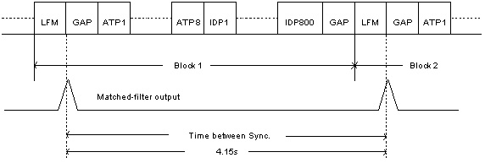
Fig.1: Data Structure with LFM signal for synchronisation

In our system, the binary input data are parsed to each subchannel with fixed number of bits for system initialisation. The number of bits for each subchannel is determined by measuring the SNR of each subchannel during startup. As our system is half-duplex there is no feedback signal back to the transmitter. Therefore a fixed number of bits is used instead of varying bit numbers.

The discrete complex multicarrier modulation signal [16] can be represented for $n^{\text{th}}$sample by:
$s(\text{nT})=\frac{1}{N}\sum_{k=0}^{N−1}{A_{k}}e^{j(2{nπf}_{k}T+φ_{k})}$ (4)

The sampling frequency is $1/T$ and the period of one data symbol is $2\text{NT}$ with inter-modulation frequency domain. The frequency,$f_{k}$, is given by:$f_{k}=f_{0}+kΔf$where $f_{0}$ is the lowest frequency of the signal spectrum and $Δf=1/{\text{NT}}$ is the frequency separation between carriers.

System Configuration

Fig. 2 shows a block diagram of the system. In the transmitter, a serial-to-parallel (s/p) buffer, adaptive threshold packets, MFSK modulator, LFM signal packet and parallel-to-serial (p/s) buffer are generated by a DSP TMS320C542. Also synchronisation, s/p and p/s buffers, MFSK demodulator and threshold learning are performed by a DSP unit in the receiver.

In the transmitter, the input data is first transmitted from a PC to the Underwater Acoustic Modem via an RS232 link. The data is then converted from serial to parallel form by a serial-to-parallel buffer. The binary input data are parsed to each subchannel with one bit. Therefore there are 48 parallel bits represented by 48 frequency components, so the parallel data bits can be modulated by multicarrier modulation.

To overcome the multipath fading, eight adaptive threshold packets are added at the front of input data sequence before transmission. Each packet contains 48 bits. The odd packets are [101010…101010] and even packets are [010101…010101]. This is used as a reference signal for the receiver to estimate the channel, and then the IFFT algorithm is used for modulation.

As mentioned above, there are 48 frequency components within 43kHz to 53kHz. They are equally distributed in the frequency range, so that the frequency separation between carriers is $Δf=\frac{\text{53}k−\text{43}k}{\text{48}}≈\text{200}\text{Hz}$. The choice of number of carriers is determined by the implementation in the DSP. The TMS320C542 is a 16 bits (one word) fixed point DSP, so that multiples of 16 bits are used due to easy implementation. In the system, 48 bits (3 words) are used for each data packet. Also, the choice of the number of tones is a trade-off between the system sensitivity to multipath and practical implementation constraints [17].

After IFFT modulation, the data is converted from the frequency to time domain. At that time, the LFM signal is implemented at the front time slot of the data sequence. This is used for synchronisation in receiver.

In the receiver, some of the noise is reduced using a bandpass filter of 40kHz to 60kHz. The matched-filter captures the LFM signal from the received signal, which indicates the start of the data sequence. The output of this correlation provides an estimation of the channel that is used to select the pulse with the most energy for synchronisation. Then

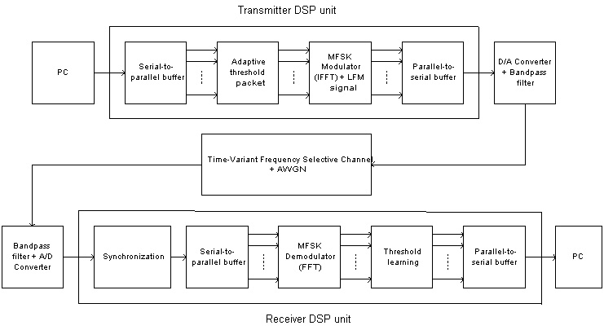
Fig.2: System Configuration

the data sequence is demodulated by the FFT algorithm. The data packets are converted from the time-domain to frequency-domain so that decoding can be take place in the error correction algorithm.

Once synchronisation has been achieved, threshold learning can be used to calculate the channel characteristic. Because the acoustic channel is a time varying channel, a fixed threshold cannot work well in the system. Therefore, the threshold of the detector is changed by transmitted reference packets at each data sequence. These change every 4.15s of the data sequence. Adaptive threshold in frequency-domain is used and the training signal is sent out repeatedly after each time the LFM signal was send. At the receiver, the frequency-domain's threshold is calculated from the known training signal and the received training signal. According to the received training signal's frequency-domain characteristic, the adaptive threshold is calculated. This can be used to estimate the channel characteristic. Depending on the acoustic channel, an equaliser/echo canceller may be inserted into system at this point; otherwise the output of the FFT is passed to an error-correction algorithm [17].

Implementation of Wavelet based of Multi-Frequency Modulation

A wavelet is a signal having desirable characteristics, such as localisation in time and frequency, orthogonality across scale and translation. These properties such as orthogonality over scale and translation are suitable for used as modulating waveforms in a communication system [18]. A WMFM is in place of MFSK in the system. The carrier channels can be shared by more than one bit in order to maintain the channel capacity. This multi-frequency diversity scheme has advantages in mobile communications where multipath and Doppler fading effects may introduce severe distortion. If the data at a particular frequency is corrupted by intersymbol interference (ISI) or some other form of distortion, the redundant data at another frequency can be used for demodulation at the receiver [19].

Let $S∈ℜ^{N}$be the symbol, where $S∈\left\{α_{1},α_{2},…,α_{N}\right\}$ and$α_{i}∈\left\{1,0\right\}$ represents the i^{th} data bit. For each bit$α_{i}$, it is mapped to $M$ frequency components. The transmission of a symbol can be synthesised similar to the MCM as follows
$f(t)=\sum_{i=1}^{N}{α_{i}ψ_{i}(t)}$ (5)
where $ψ_{i}(t)=w(t)⋅\sum_{k=1}^{M}{A_{k}^{i}ϕ_{k}^{i}}$, and $ϕ_{k}^{i}=e^{j(2{πf}_{k}^{i}t+φ_{k})}$. $A_{k}^{i}$determines the amplitude of the function $ϕ_{k}^{i}$, $f_{k}^{i}$is the base carrier frequencies, $φ_{k}$is the phase and $w(t)$is a Gaussian windowing function defined by $w(t)=\frac{1}{\sqrt{2π}σ}e^{−(t−m_{t}{)^{2}}/2σ^{2}}$. Also, the maximum magnitude of $w(t)$is $\left|w(t)\right|=1$. A typical $ψ_{i}(t)$with $M=A_{k}^{i}=1$and$φ_{k}$=0 is shown in Fig. 3.
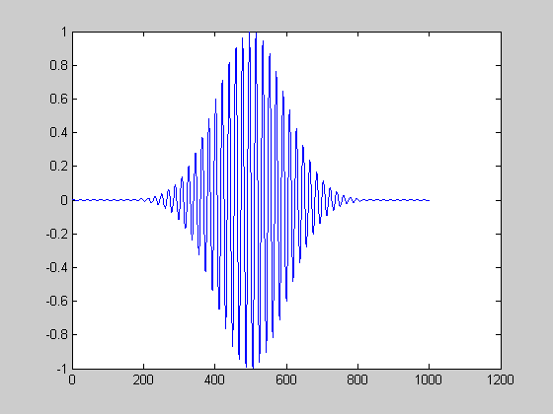
Fig.3: An example of wavelet base

Assume there is a multipath fading channel, so that
$$y(t)=\sum_{i=1}^{N}{α_{i}ψ_{i}(t)+\sum_{d=1}^{L}{\sum_{i=1}^{N}{α_{i}ψ_{i}(t−τ_{d})⋅β^{d}u(t−τ_{d})}}+η(t)}$$
where $β^{d}$,$u(t−τ_{d})$and$η(t)$represents the path attenuation, time delay function and received noise respectively.

Define $θ_{i}$ be the projection of $y(t)$onto$ψ_{i}(t)$over the closed interval$\left[p,q\right]$,
$θ_{i}=\left\langle y(t),ψ_{i}(t)\right\rangle ≡\int{y(t)ψ_{i}(t)\text{dt}}$ (6)
Let ${\bar{η}}_{i}=\left\langle η(t),ψ_{i}(t)\right\rangle$, then let
$\begin{aligned}r_{\text{ij}}(τ_{d})=\left\langle ψ_{i}(t−τ_{d})⋅u(t−τ_{d}),ψ_{j}(t)\right\rangle \\ \int{ψ_{i}(t−τ_{d})u(t−τ_{d})ψ_{j}(t)\text{dt}}\end{aligned}$ (7)
If $τ_{d}=0$, then (7) becomes $r_{\text{ij}}(0)=\left\langle ψ_{i}(t),ψ_{j}(t)\right\rangle$.

So that
$\left[\begin{matrix}θ_{1} \\ θ_{2} \\ ⋮ \\ θ_{N}\end{matrix}\right]=\left[\begin{matrix}r_{\text{11}}(0) & r_{\text{21}}(0) & ⋯ & r_{N1}(0) \\ r_{\text{12}}(0) & r_{\text{22}}(0) & ⋯ & r_{N2}(0) \\ ⋮ & ⋮ & ⋱ & ⋮ \\ r_{1N}(0) & r_{2N}(0) & ⋯ & r_{}(0)\end{matrix}\right]\left[\begin{matrix}α_{1} \\ α_{2} \\ ⋮ \\ α_{N}\end{matrix}\right]+\left[\begin{matrix}{\bar{η}}_{1} \\ {\bar{η}}_{2} \\ ⋮ \\ {\bar{η}}_{N}\end{matrix}\right]$ or
$θ=R(0)α+\bar{η}$ (8)
Then (8) becomes $α=R^{−1}(0)θ−R^{−1}(0)\bar{η}$. Let $\bar{α}=R^{−1}(0)θ$ be the ideal detection. The error of detection is $\left\|α−\bar{α}\right\|=\left\|R^{−1}(0)\bar{η}\right\|=\left\|e\right\|$. The good detection depends on the size of$e$.

Similarly, we can compute the projection vector$θ$ with$τ_{d}≠0$,
$θ=R(0)α+\sum_{d=1}^{L}{β^{d}⋅R(τ_{d})α}+\bar{η}$ (9)
From (9), it can be rewritten as
$α=\bar{α}−(R^{−1}(0)Cα+R^{−1}(0)\bar{η})$ (10)
where $C=\sum_{d=1}^{L}{β^{d}R(τ_{d})}$ and $\bar{α}=R^{−1}(0)θ$.
If $C$ & $\bar{η}$ are zero, then $α$ can be found by $R^{−1}(0)θ$ easily. By careful selection of the frequency diversity scheme, frequency diversity scheme is shown in the example, the term $\left\|R^{−1}(0)Cα+R^{−1}(0)\bar{η}\right\|≤\left\|R^{−1}(0)Cα\right\|+\left\|R^{−1}(0)\bar{η}\right\|$can be made small and hence the detection is improved. In multipath environment, we send a training sequence to estimate $\left\|R^{−1}(0)Cα+R^{−1}(0)\bar{η}\right\|$. And then we can define the boundary of decision threshold by taking standard deviation to the $R^{−1}(0)θ$. The boundary is between the mean $±$ standard deviation of the received training sequence. Then the bit information can be found by$R^{−1}(0)θ$. If the recovered bit information are located inside the boundary, it is defined to 1’s. Otherwise, it is 0’s.

Results

In an example, we choose 48 carriers with initial frequency $f_{0}=\text{43}\text{kHz}$ and frequency separation$Δf=\text{200}\text{Hz}$ where$f^{i}=f_{0}+i⋅Δf$, $i=1,…,\text{48}$. The test channel has two multipaths with delay time$2\text{.}\text{009}\text{ms}$and$5\text{ms}$, and with attenuation -14db and -20db respectively. For the wavelet base, we choose$M=3$, $A_{i}^{i}=1$, $A_{2}^{i}=0\text{.}\text{25}$ and$A_{3}^{i}=0\text{.}\text{25}$. Let the bit assignment be$S_{j}→\left\{f_{j}^{j},f_{j+\text{12}}^{j},f_{j+\text{27}}^{j}\right\}$, where the indices are computed with modulo 48. Therefore an information bit is transmitted over a number of carriers and hence the fading effect can be minimised. However, some inter-bit-carrier interference exists and that can affect the detection. The assignment of carriers to a symbol is an important issue while it is not discussed in this paper. Fig. 4 shows the bit-to-channel assignment.

Fig.4: Bit assignment with frequency diversity scheme

In WMFM technique, the symbol can be recovered by the equation (8). Fig. 5 shows the recovered symbol with no multipath fading. The red squares represent the original bits and blue circles represent the recovered bits. Fig. 6 shows the symbol recovery with one bit mapping to one frequency component in multipath fading. The red squares represent the original bits and blue circles represent the recovered bits. The value of upper red line is (mean + standard deviation) of training sequence and bottom line is (mean – standard deviation) of training sequence. The region between two red lines is threshold region. Bits inside this region are detected as 1s. Otherwise, bits act as 0s. The bit error rate (BER) is 0.1458. Fig. 7 shows the symbol recovery with frequency diversity in a multipath environment. The BER is 0.1042.

For an extreme case, it is easy to see the benefits of the frequency diversity method in WMFM compared to a non-frequency diversity WMFM. For example, if the channel has multipath fading with a delay time$2\text{.}\text{009}\text{ms}$and attenuation -2dB. Fig. 8 and Fig. 9 show the symbol recovery in non-frequency diversity WMFM and frequency diversity WMFM respectively. At the 30th bit in Fig. 9, it acts as 1’s while it is in threshold region. However, the same bit wrongly acts as 0’s in Fig. 8. Therefore, the frequency diversity method can overcome the serious fading. Fig. 10 shows the relationship between bit error rate and intensity of side paths.

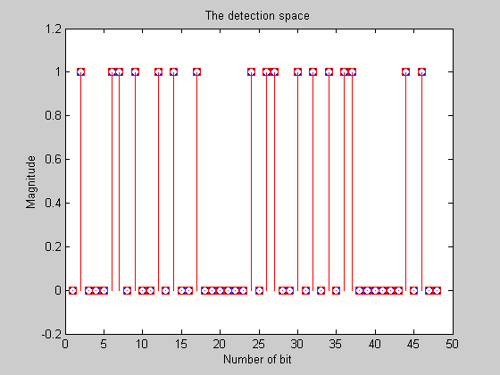
Fig.5: Symbol recovery with no multipath fading

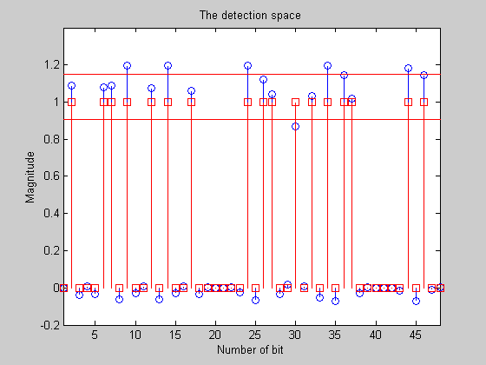
Fig.6: Symbol recovery with multipath fading

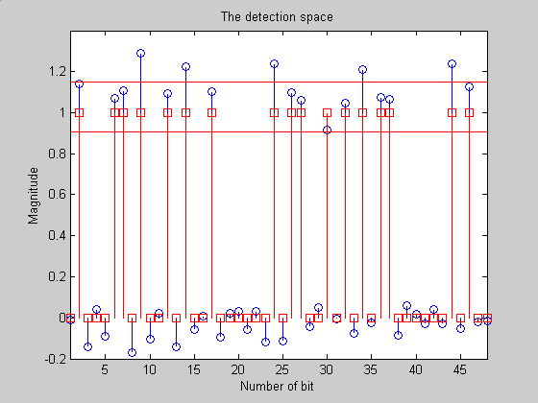
Fig.7: Symbol recovery with frequency diversity in multipath environment

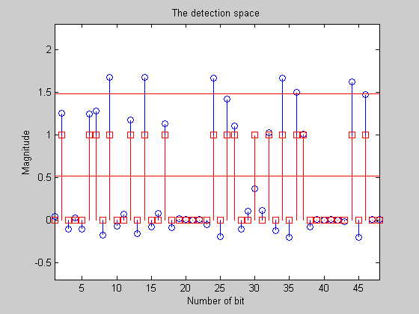
Fig.8: Symbol recovery in multipath environment

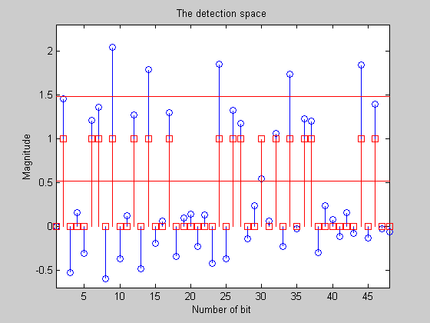
Fig.9: Symbol recovery with frequency diversity in multipath environment

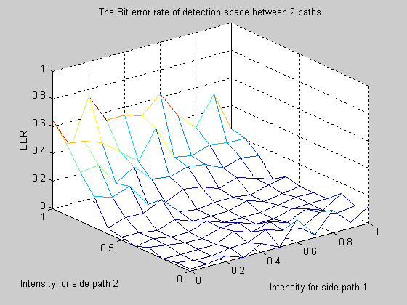
Fig.10: Bit error rate between 2 side paths

Conclusions

In this paper, a multicarrier modulation underwater acoustic system has been developed in the real time underwater acoustic communication. The system performed at a data rate of 10kbps over 1km. The error rate gets worse in the multipath fading problem. However WMFM can minimise the fading without reducing channel capacity. The future work will consider in the bit-to-channel assignment while it is an important issue.

Acknowledgement

This work has been carried out using funding from City University Strategic Research Grant No. 7001137

Reference

[1] D.Z. Liao, S.O. Harrold and L.F. Yeung, “An underwater Acoustic Data Link for Autonomous Underwater Vehicles”, IEEE Int. Conf. in Circuit and Systems, p28-33, Singapore, July 1995.

[2] S.O. Harrold, D.Z. Liao and L.F. Yeung, “Ultrasonic Data Communication Along Large Diameter Water-filled Pipes”, IEEE Int. Conf. M²VIP, Hong Kong, 1996.

[3] Yinghui Li, S.O. Harrold and L.F. Yeung, “Experimental Study On Ultrasonic Signal Transmission With The Water-Filled Pipes”, IEEE Int. Conf. M²VIP, Sept 1997, Australia.

[4] B. Li, S.O. Harrold, R. Bradbeer and L.F. Yeung, "An Underwater Acoustic Digital Communication Link", in Mechatronics and Machine Vision, (J Billingsley (Ed)), Research Studies Press, UK, pp 275-282, 2000

[5] M. Siderius, M.B. Porter and P. Hursky, “Measurements and Modelling Comparisons of Underwater Communications Performance at three Shallow-Water Sites”, OCEANS 2003, Volume: 4, 22-26 Sept. 2003, pp.1773-1779.

[6] M. Stojanovic, L. Freitag & M. Johnson, “Channel-Estimation-Based Adaptive Equalization of Underwater Acoustic Signals”, OCEANS '99 MTS/IEEE, Riding the Crest into the 21st Century, vol.2, 1999, pp.985-990.

[7] M. Siderius, M. B. Porter and V. K. McDonald, “Experiments Study Underwater Acoustic Communications”, Sea Technology, Arlington: May 2004. Vol. 45, Issue 5, pp.42-48.

[8] S. Azou, G. Burel, L. Le Duff and C. Pistre, “Sea trial results of a chaotic direct-sequence spread spectrum underwater communication system”, OCEANS 2003, Vol. 3, 22-26 Sept. 2003, pp.1539-1546.

[9] H. K. Yeo, B. S. Sharif, A. E. Adams & O. R. Hinton, “Multiuser Detection for Time-Variant Multipath Environment”, Proceedings of the 2000 International Symposium on Underwater Technology, 2000, pp.399-404.

[10] H. A. Leinhos, “Block-Adaptive Decision Feedback Equalization with Integral Error Correction for Underwater Acoustic Communications”, OCEANS 2000 MTS/IEEE Conference and Exhibition, vol.2, 2000, pp.817-822.

[11] A. W. Rihazek, Principles of High-Resolution Radar, Peninsula Publishing, 1985, pp.226-231.
[12] J.A.C. Bingham, ‘Multicarrier Modulation for Data Transmission: An Idea Whose Time Has Come’, IEEE Communications Magazine, 1990, pp.5-14.

[13] J. G. Proakis, Digital Communication, 3rd Edition, McGraw-Hill,Inc, New York, 1995, pp.689-690 and 663-666.

[14] I. Lee, J.S. Chow & J.M. Cioffi, ‘Performance Evalution of a Fast Computation Algorithm for the DMT in High-Speed Subscriber Loop’, IEEE Journal on Selected Areas in Communications, 1995, pp.1564-1570.

[15] A.D. Rizos, J.G. Proakis & T.Q. Nguyen, ‘Comparison of DFT and Cosine Modulated Filter Banks in Multicarrier Modulation’, IEEE Global Telecommunications Conference, 1994, pp.687-691.

[16] W. K. Lam & R. F. Ormondroyd, “A Coherent COFDM Modulation System for A Time-Varying Frequency-Selective Underwater Acoustic Channel”, 7th International Conference on Electronic Engineering in Oceanography, 23-25 June 1997, pp.198-203.

[17] J. A. Catipovic & L. E. Freitag, “High Data Rate Acoustic Telemetry for Moving ROVS in a Fading Multipath Shallow Water Environment”, Proceedings of the Symposium on Autonomous Underwater Vehicle Technology, 1990, pp.296-303.

[18] S. Srinidhi, J.G. Proakis and M. Stojanovic, “Wavelet based modulation for frequency hopped spread spectrum communications”, IEEE 49th Vehicular Technology Conference, Volume: 2, 16-20 May 1999, pp.904 -908.

[19] M.J. Manglani and A.E. Bell, “Wavelet modulation performance in Gaussian and Rayleigh fading channels”, IEEE Military Communications Conference, Communications for Network-Centric Operations: Creating the Information Force, Volume: 2, 28-31 Oct. 2001, pp.845 -849.

