An introductory course in electronic engineering using a collaborative problem based learning approach in a studio environment

Author:

Robin Bradbeer, Department of Electronic Engineering, City University of Hong Kong, Hong Kong. eersbrad@cityu.edu.hk

Abstract ⎯ The City University of Hong Kong has been running a 3 year degree programme in mechatronic engineering since 1992 - the first in Asia. Over that time the content and presentation of the programme has changed to reflect the continuing evolution of the Pearl River delta and mainland China in particular. In 2002 a revised programme was introduced that resulted a substantially changed degree structure. One of the elements of this was the development of a new 'core' two-semester course in electronic engineering that was to be taken in the first year of the programme. This new course would be heavily problem-based learning in nature, with the use of small groups working in a collaborative manner. At the same time, it was decided to use the integrated teaching studio paradigm that had been successfully introduced some years previously. The new course combines simulation and practical laboratory around a number of problem-based learning objectives. This paper presents the results of the first year of implementation with reference to the new programme, as well as the resulting further development of the studio-based teaching techniques.

Index Terms ⎯ mechatronic engineering, problem-based learning, integrated studio teaching

Introduction
The introduction of the 3-year Mechatronic Engineering bachelor’s degree in the Department of Manufacturing Engineering and Engineering Management (MEEM) at City University of Hong has been well documented [1-5]. Since the start of the programme two major changes in its structure have taken place. In 1995/6 the university changed from the traditional UK 3-term year to a US-type 2-semester year. The original course structure was updated at this time. In 2001/2 the whole programme was revised to take into account the changing nature of mechatronics over the previous decade, as well as the evolution of industry in the Pearl River delta region of China, where most of the programme graduates would work.
Coupled with these changes were the university requirements that the number of contact hours be reduced, and more “out of discipline” courses be introduced. This “double whammy” also coincided with a general reduction in the factual knowledge and understanding of the students and grade inflation in the entrance qualifications.
This paper will concentrate on the electronic engineering aspects of the programme and the development of two new courses that have been developed to provide a basic knowledge of electronics so that efficient articulation with later courses is achieved.

Changes in Programme structure
Figure 1 shows a model study path for the previous programme. This structure follows a traditional engineering degree structure, with a high number of required, or core, courses, and a limited number of elective courses, in the final year. The language and Chinese Civilisation courses can actually be taken at any time in the normal three years of study, and are a university requirement for all degree courses, regardless of discipline. The students must show a competence in both English and Chinese to graduate. Although courses can be taken in any order, as long as pre-requisite and pre-cursor requirements are met, the majority of students follow the model study-path, as this is the one recognised by the appropriate professional institution for membership.
It should also be noted that the electronic engineering courses are taken in all three years of the course, and are core or required courses. They also account for around 23% of the engineering content of the programme. The students had to choose one core elective course and three out-off-discipline (OOD) electives in the final year, although the OOD courses were quite often taken any time during the three year programme. This meant that the students had little choice but to follow the department’s suggested study path, especially as the professional institutions represented in Hong Kong (mainly IEE (UK) and HKIE) had approved this study path as being eligible for exemption from the entry path to professional engineer (CEng) status.
The new course structure followed some loosening of the professional criteria, especially since most institutions in the countries allied with the Washington Accord [6] had relaxed their core programme requirements when introducing the master’s degree entrance requirement for professional membership.
At the same time, the university reduced the number of credits needed to achieve final degree standard from 105 to 99. This meant that a number of courses had to be eliminated. This led to a rethink of the overall programme structure, which meant more of the core courses were to be offered as electives, and electives would be available in the second and third years of the programme. Figure 2 shows the new programme structure, along with a model study path. The programme core consists of 78 credit units. Three elective courses can be chosen from amongst nine offered in the mechanical group, four elective courses from ten in the electronics, control and computers group, and two from six in the systems and management group. Full details of the elective courses can be found on the programme web site [7].
This redesign meant that the number of core electronics courses was reduced from six to three, with one offered as an elective. This did not mean that the percentage of electronics in the programme was diminished; some of the courses offered by MEEM now included the electronics component within those courses. However, the basic electronics needed to support the programme was reduced from three to two courses, and this needed a complete rethink on how these courses were taught.

Changes in Student Entrants
Not only has the format of the programme changed over the past few years. There has also been a marked change in the type of students entering the course. Allied to this has been the gradual grade inflation of the entrants’ qualifications. These have been described by the author elsewhere [8-10]. These show that although the entrance level examination scores of students on the BEMTE programme have gone up over the past six years, the students’ scores on a pre-test given at the start of the first semester of the first year, have gone down. At the same time, the level, breadth and understanding of the “pre-knowledge” of the subject that the entrants bring with them from previous schooling has also been decreasing, especially in the area of binary arithmetic and Boolean algebra. There has also been a decrease in general mathematical and physics understanding. The two trends are illustrated in Figure 3, which shows the increase in entrants’ grades compared to the decrease in basic knowledge of the entrants.
Consequently, as also described in [8], a major change had already taken place in the introductory electronics courses in the previous programme, between 1996 and 2002. With the reduction in hours for the introductory electronics cut by 35% in the new programme, a complete rethink on how to present the courses was undertaken. At the same time as changes to the syllabus described in [8] were introduced between 1996 and 2002, it was decided to implement the first two Basic Electronics courses, i.e. those for the first year students, in Integrated Teaching Studio (ITS) mode [11-16]. By the time the recent changes in the programme structure were made in 2002, the use of ITS mode had been fully implemented. Therefore, it was natural to consider using the ITS approach coupled with more problem-based learning material for the new courses.

The New Course Syllabuses
The previous three courses that were to be concatenated into two, covered a fairly standard introductory electronics syllabus, starting with physical fundamentals, semiconductor theory, semiconductor devices, circuit theorems and phasors. This was then followed by transistor amplifiers, operational amplifiers, combinational digital circuits, and power devices. The third course, the second year one, covered sequential logic circuits, op-amp applications and active filters, counters, registers and a/d and d/a converters.
It was this coverage of a large area of electronics that had to be retained, but using one third less time. It also had to assume that the students were not as well versed in basic knowledge as some years earlier. As the decision had been made to use a PBL approach within the ITS, it was agreed that most of the introductory material to do with physical fundamentals and circuit theory be discarded. This material would then be included on a ‘need-to-know’ basis as the course progressed, and would be included as part of the introduction to the PBL material. At the same time, some of the material could be included in other courses, on a similar basis, as necessary. For example, although some knowledge of Boolean relationships would be needed for designing counters, it was not necessary to know all the various theorems and rules. Those not covered here could be taught in later courses dealing with PLCs, for example.
Similarly, although circuit theorems were not taught very deeply as a separate subject, after a brief introduction to the concepts, were introduced as needed, for example, when it came to transistor circuit design. Thus the new course syllabuses differed from normal by just presenting a series of subject headings, within which was a more complex mix of subjects. The list below gives these outline headings:

Semester A Circuit analysis techniques; revision of basic circuit theorems: Basic discrete semiconductor devices: The transistor as an amplifier: The transistor as a switch: Integrated circuit fundamentals.

Semester B Analogue electronic systems; operational amplifiers; active filters: Digital electronic systems: K-map simplification of Boolean expressions; sequential logic circuits: Data conversion devices: D/A and A/D converters.

Within these broad headings, the syllabus was broken down into a number of smaller areas, most of which were not taught as separate subjects, but were designed to be covered within the PBL structure. For example, the heading “The transistor as an amplifier” would be based on a design study, which the students had to undertake, but which included all the usual elements, such as characteristics, biasing, frequency response, input and output impedances etc. This would be true also for most of the other main subject headings, although some, such as the transistor as a switch, were designed to be taught in the more traditional manner.

The Teaching Methodology
The classroom was arranged along fairly typical ITS lines. The class would be grouped in small groups, of either two or three students. They would keep these groups for the whole semester. A brief lecture would be followed by some interactive tutorial work, before the students were requested to start some preparation work for the PBL component. This might involve reading through a handout/lecture notes, looking up some web pages or manufacturers’ web sites, or carrying out a simulation exercise. Although this preparation work was initially designed to be done outside the classroom before the class formally started, it proved difficult to implement, mainly because the students had little experience of this type of teaching. Consequently, some of the preparation work was done in scheduled class time.
Once the preparation work was completed, this was assessed by the instructor, and comments made. If the instructor noticed that students were having problems with some aspects of the work, then an additional lecture/tutorial period could be used to explain things in more detail, or just to reinforce what was done previously. It was clear over the course of the first semester that this would be a continuing requirement, so time was built in to later classes to allow for this.
The PBL assignments emphasised design over detailed analysis. Interactive exercises were carried out, mainly using the EDEC courseware [17]. This is a design oriented programme that allows students to work their way through material at their own speed, as well as allowing the instructor to use it for presentation purposes.
Finally, using the virtual laboratory [16], the students could physically build their designed circuits and test them against both their calculated and simulated results. All the design studies require a formal report to be written, detailing the design process and the test results. Students have to keep a lab log of their work, and this is where the preparatory design work is recorded, to be assessed and commented on by the instructor. All assessments are based upon and individual mark for the lab log, and a group mark for the report.
There were four design projects over the two semesters. These were: BJT amplifier; digital logic IC characteristics; operational amplifier applications, including active filters; and sequential logic counters.

Examples of Two PBL-based Design Studies

BJT amplifier
The first example is the design of a single transistor amplifier. Before the design study begins, one class period (2 hours) is used to give an interactive lecture/tutorial, using the EDEC material, on basic transistor theory, for both BJT and FET. Using this material the students can understand the basic transistor characteristics, and fundamentals of biasing.
Next, they are given a design specification for a single BJT amplifier using voltage-divider biasing. They are given the expected no-load voltage gain, input and output impedances and the frequency response required. The first part of the preparation involves looking at the class notes/EDEC courseware and any on-line or off-line reference material, to come up with a basic design. They are asked to plot the common emitter characteristics of the transistor to be used, with data from their own measurements. A load-line is drawn on these characteristics as part of the design process. This is then commented on by the instructor, and then the students use MultiSIM2000 to simulate the amplifier and see if it meets the design criteria. At this point, the instructor will take the class through a model design process so that they can check their methodology and make any corrections to the circuit. Finally, they can test the bread-boarded circuit. Ten hours is allocated for this design study, although it proved not long enough for many students in the class. As mentioned above, this seems to be because they do not have good or adequate time planning skills, so their out-of-class time is not used efficiently [18-19].

Sequential logic counter
The second example of a design study is for a sequential logic counter. In a similar way to the first example above, before the design study begins two class sessions used to introduce the basic principles of sequential logic circuits, with finite state machines and counter design highlighted. The students also back-up their basic knowledge with some self-instruction using the EDEC courseware. They are then given a three part design brief. The first takes an existing counter and analyses the count sequence. Next, the students have to design a specific counter, a simple 3-bit Gray code counter. After the instructor has commented on the preparatory design, this is simulated, then built and tested. Finally, they design, build and test a traffic light sequencer.
The three other design studies mentioned above follow very similar formats; all emphasise small group activities with problem-solving as an integral part of the studies. The instructor works more as a facilitator than a teacher, although, owing to the lack of essential background knowledge, some amount of ‘guiding’ is necessary if the students are to complete a project satisfactorily.

Conclusions
It is clear from comments from students, as well as the feedback from the university’s Teaching Feedback Questionnaire, (student rating of teachers feedback) that students enjoy the courses. This feedback indicated a far higher student satisfaction than with the previous courses. However, owing to the lack of efficient time-management skills mentioned above, many complained that they did not have enough time to complete the design studies. This will need to be monitored more closely in the coming year to see if they need to be reduced in scope, if not content.
The courses assessment is based upon a mixture of coursework and examination. During the course two homework assignments and three quizzes were given, along with a final examination. The examination emphasised design over analysis, with approximately 40% analysis and 60% design and description. The examination results were most encouraging with higher average GPA than the previous courses even though the examinations were of similar standard.
Although it is too early to draw any major conclusions from the results so far, it is clear that the initial objectives have been achieved. The PBL-based approach used clearly kept the students’ interest, and added to the benefits of the integrated studio environment. Lessons learned from this first year of operation will be used to modify the course in an iterative manner, especially with regard to the amount of time needed to complete the design projects. The major challenge is to reduce the amount of material covered whilst keeping the learning outcomes similar to those at present.
The next aspect of the new course design to be studied will be the level of interaction and articulation with other courses, as well as whether the reduction in course hours for the electronics courses will affect the basic knowledge and understanding needed for those courses.

Acknowledgement
I would like to acknowledge the assistance given to me by my colleagues in the Department of Manufacturing and Engineering Management at CityU Hong Kong, especially those involved with the BEMTE programme.

References
- Bradbeer, R., Rao K. P., “Student-centred activity-based learning within a Mechatronics Degree course”, Proceedings of International Conference on Recent Advances in Mechatronics, August 1995, Istanbul, Turkey, Vol. 1, pp. 247-254,
- Venuvinod, P. K., Rao, K. P., “A Mechatronic Engineering curriculum for professional education”, International Journal of Engineering Education, Vol. 9, 1993, pp. 403-416
- Venuvinod, P. K., Rao, K. P., “A Mechatronic Engineering degree course to meet the needs of Hong Kong”, Proceedings of the International Conference on Mechatronics and Machine Vision in Practice, September 1994, Toowoomba, Australia, pp. 52-57
- Venuvinod, P. K, Chan, L. W., Leung, D. N. K., “Development of the first Mechatronic Engineering degree course in the Far East”, Mechatronics, Vol. 3, No. 5, 1993, pp. 537-541
- Kamineni R P, Geddam A and Tso S K, "A perspective on mechatronic education: undergraduate programme at the City University of Hong Kong", Proceedings of the Sixth International Conference on Manufacturing, Detroit, USA, Vol.2, September 2000, pp 625-630.
- http://www.washingtonaccord.org
- http://www.cityu.edu.hk/cityu/dpt-acad/fse-me.htm
- Bradbeer, R, "Entrance grade inflation and its effect on the first year syllabus" Proceedings International Conference on Engineering Education, Manchester, UK, 2002
- Bradbeer, R, "Changing computer literacy and its effect on engineering education", Proceedings International Conference on Engineering Education, Manchester, UK, 2002
- Bradbeer, R, EdD thesis, University of Durham, UK, in preparation
- Bradbeer, R., "An integrated studio approach to teaching basic electronics to first year mechatronics degree students", Proceedings of 2001 IEEE/ASME International Conference on Advanced Intelligent Mechatronics, Como, Italy, July 2001, pp 1118-23
- Bradbeer, R., "Integrated Studio Teaching and its effectiveness for a first year Electronic Engineering course", 2nd Hong Kong Conference on Quality in Teaching and Learning in Higher Education, Hong Kong, May 2001
- Bradbeer, R., "Teaching introductory electronics in an Integrated Teaching Studio environment", International Journal of Engineering Education, Vol. 15, No.5, Nov 1999, pp344-352
- Bradbeer, R., "Developing an Introductory Electronics course for use in an Integrated Teaching Studio", in Current Practices in Multimedia Education (R. Bradbeer (Ed)), City University Press, October 1999, pp 91-100
- Bradbeer, R., "The experience of teaching introductory electronics in an Integrated Teaching Studio environment", Proceedings of 3rd IEEE Conference on Multimedia Engineering and Education), Hong Kong, July 1998
- Bradbeer, R., "A virtual laboratory for use in an Integrated Teaching Studio", Proceedings of 3rd IEEE Conference on Multimedia Engineering and Education, Hong Kong, July 1998
- http://www.edec.co.uk
- Kwan, A. S. F., Ko, E. I., “Helping university students to manage their time better”, Proceedings of the 27th International Conference on Improving University Learning and Teaching, July, 2002, Vilnius, Lithuania.
- Kwan, A. S. F., Ko, E. I., “More on helping university students to manage their time better”, Proceedings of the 28th International Conference on Improving University Learning and Teaching, July 2003,Vaxjo, Sweden.

Figures and tables
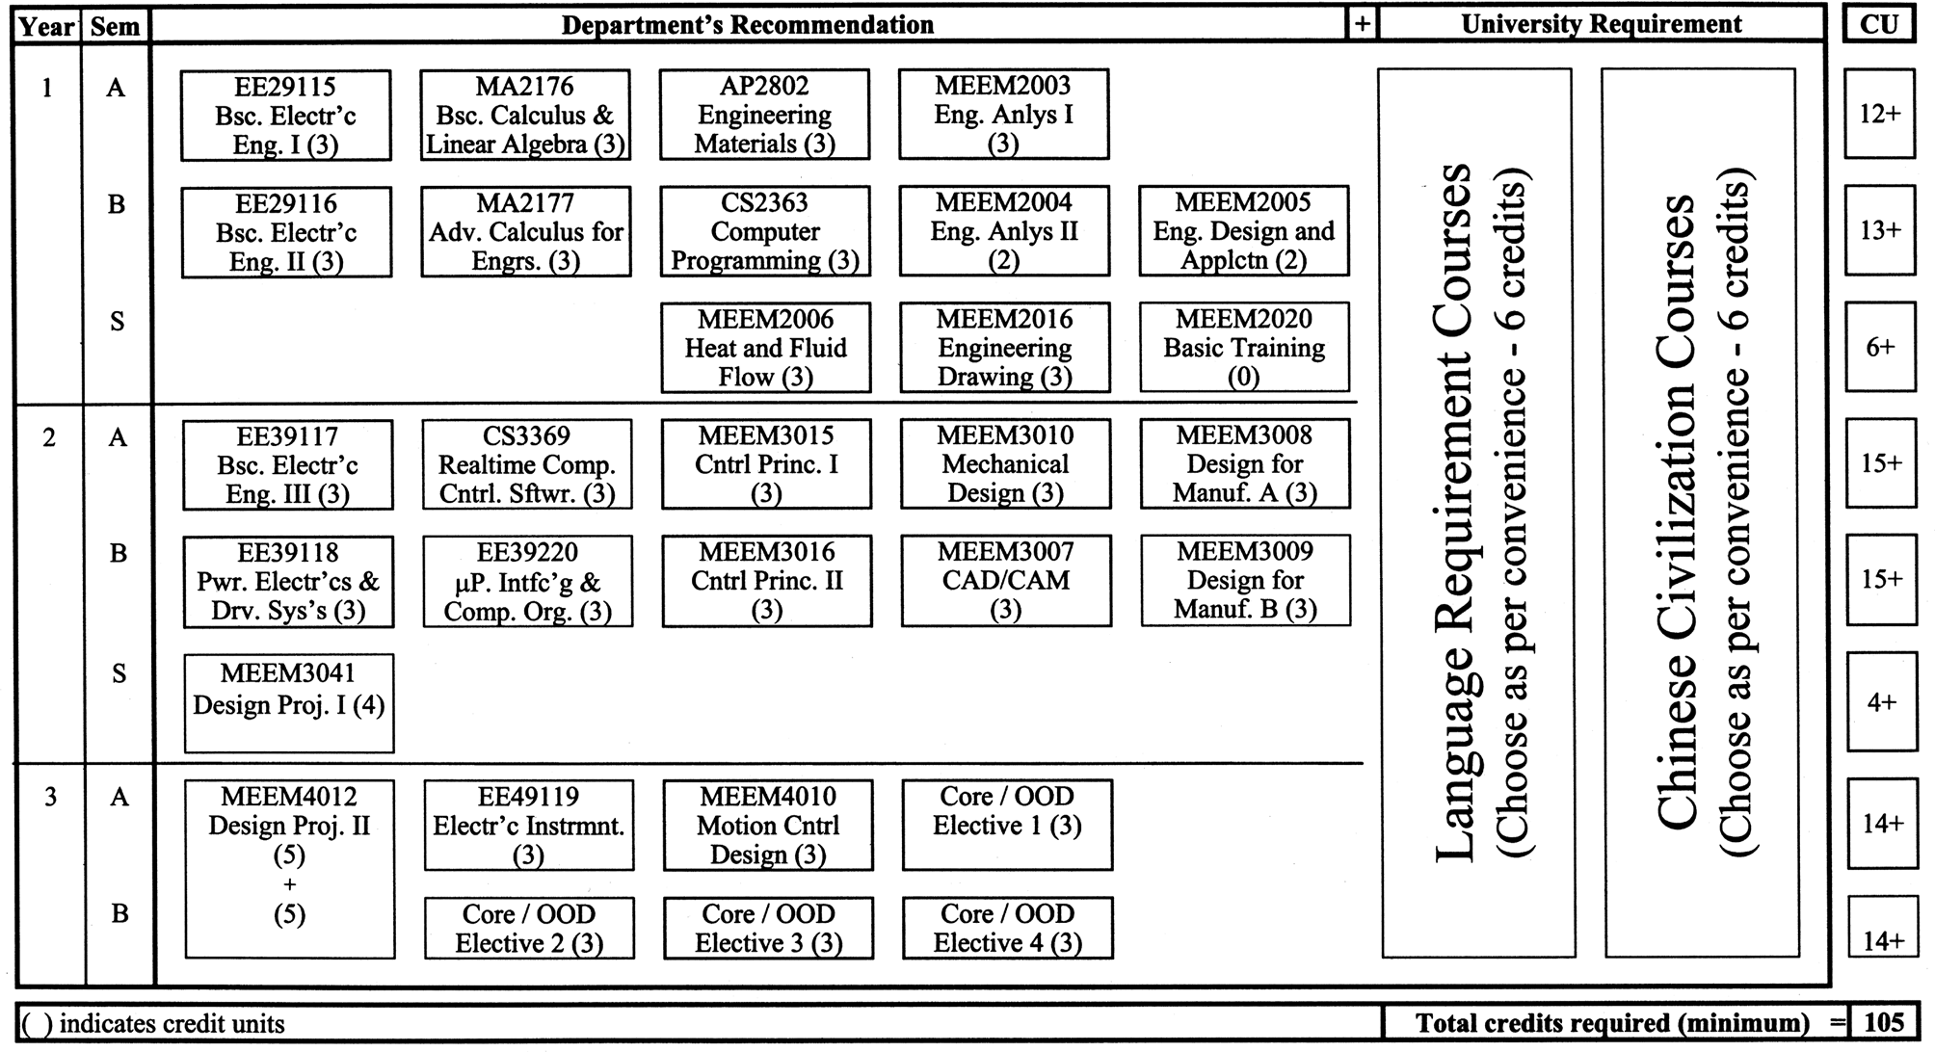
Figure 1
Model study-path for 1999 intake

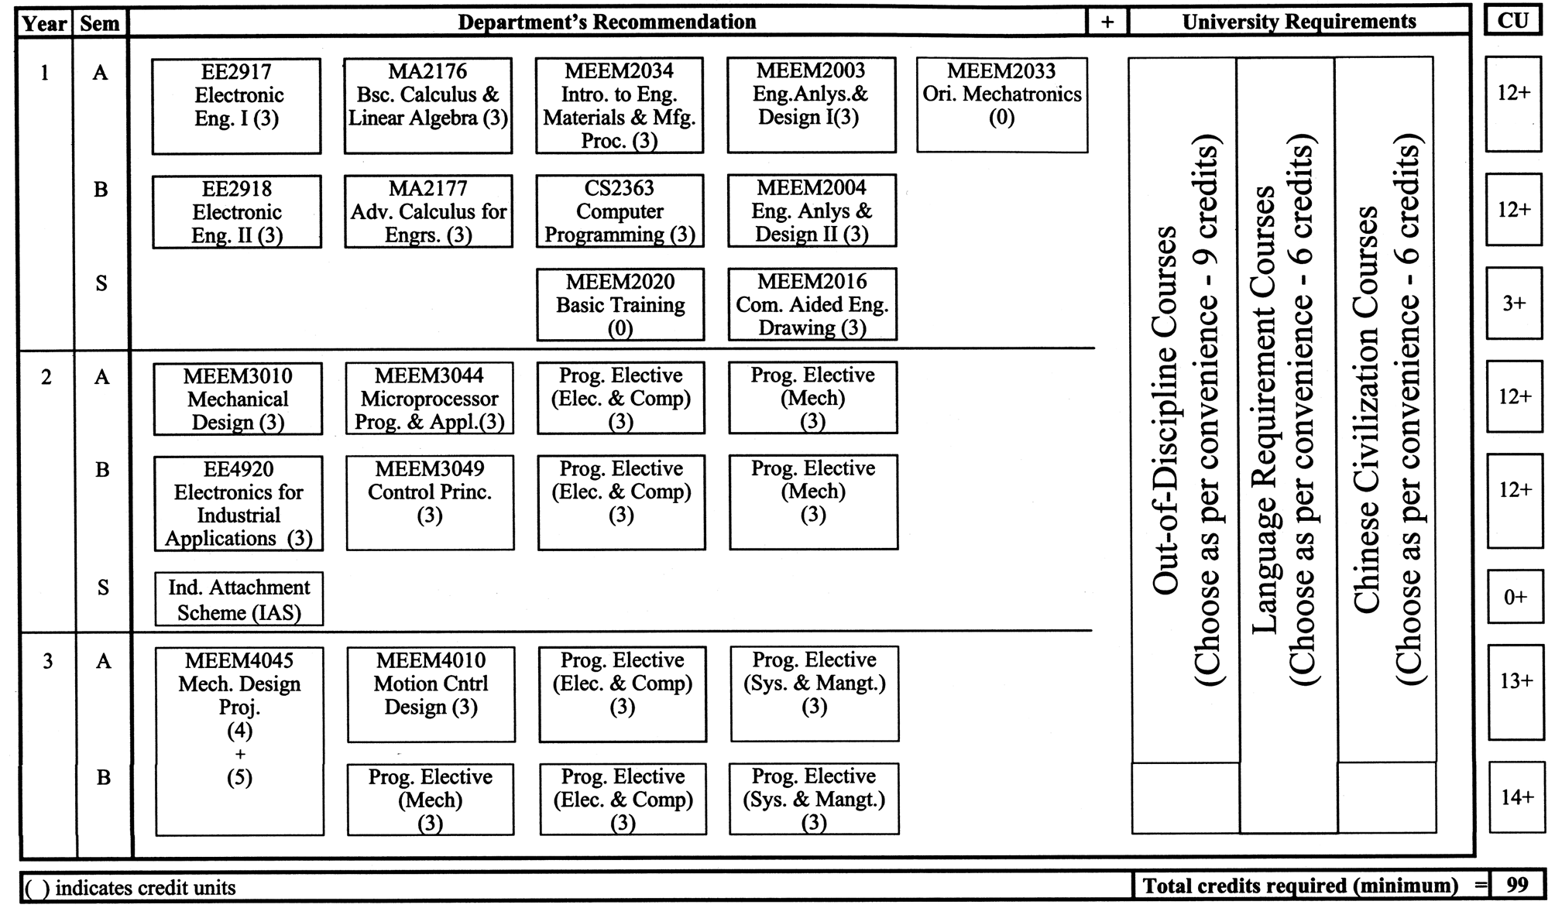
figure 2
Model Study Path for 2002 Intake

5
6
7
8
9
10
96-97
97-98
98-99
99-00
00-01
01-02
Cohort
40
50
60
70
80
Entry score
Test scores
Pre-test scores
Entry scores

Figure 3
Entry Scores vs. Pre-Test scores

