An Underwater Acoustic Digital Communication Link

Li Bin, S O Harrold, L F Yeung, and R S Bradbeer
Department of Electronic Engineering,
City University of Hong Kong

Abstract
An acoustic data link was developed primarily for the control of a pipe rover and for relaying data back to the base station. This data modem is aimed for the water filled pipe environment. A number of modulation scheme were developed, for instance ASK, MFSK for their reliability in a multi-path environment.

Key words: modem, acoustic data link, pipe communications

1 Introduction and Background
Through water communication using pressure waves at ultrasonic frequencies has been used by man for a many years, though its effectiveness and reliability has often been found wanting. A number of aquatic animals, however, communicate with each other with apparent ease, sometimes over great distances, using acoustic waves. It is the complexity of the water channel that is the problem, particularly when bounded relatively closely by media of widely different acoustic impedance. Channel imperfections are commonly numerous, being caused by water motion, density gradients, multi-paths, and the non-homogeneity of the water due to particles of solid or gaseous matter. However, over the past decade or so fast, cheap, digital signal processing (DSP) hardware has become available, enabling many workers1-7. to apply appropriate real-time DSP to enhance the communication channel and apply error correction techniques. This process has been driven by a need to send data at ever higher rates as the industry’s demands increase. Digital ultrasonic modems are now needed to carry real-time video data, requiring bit rates of at least 10 Kbs.
For the past 7 years or so, the City University of Hong Kong has followed a programme of research into underwater acoustic communications, with a particular emphasis on water filled pipes14-19.. The authors have concentrated from the start on the transmission of coded data, using either amplitude shift keying (ASK) or frequency shift keying (FSK) on an ultrasonic carrier, each bit being represented by a short burst of 10 to 20 cycles. Latterly the work has been aimed at supporting the development of an autonomous pipe inspection vehicle 16-17, one that does not require an umbilical. The inherent advantages of such a system for the inspection of large diameter water filled pipes, such as cooling water outflows, was recognised, and work has been supported by a considerable Hong Kong government grant.

2 Channel imperfections
Multi-paths can exist in almost any medium, whether bounded or unbounded. Reflections from boundaries can create signal paths between transmitter and receiver in addition to the direct path. In unbounded media, it is feasible that spurious signal paths may be created by temperature or velocity gradients. The effect of temperature gradients can be to refract a wave front such that the signal is bent round to the point of reception, so, interfering with the direct signal. Similarly a velocity gradient lying across the axis of wave propagation can cause what appears to be refraction, bending the wave front. This latter phenomenon is likely within a water filled pipe where the flow is zero at the pipe-water interface and maximum at the centre. When the acoustic signals are sent with the flow, then the wave front expands away from the axis as the signal progresses along the pipe, and when sent against the flow, the wave front is compressed into the central axis. In all multi-path situations the indirect path will be longer, so that signal bursts will be delayed in time/phase with respect to the direct signal. If direct and indirect overlap, then normal interference effects will result and signal nulls will occur as the receiver moves. It is unlikely that these nulls will ever be as low as zero since the reflected indirect signal must have a lower strength than the direct. As the difference between the path lengths increases, so bursts will no longer overlap and spurious bursts will appear within the guard space between direct path bursts. As the distance between sending and receiving points increases, so these spurious bursts move towards and eventually overlap the next direct burst.

3 Channel Equalisation
In the past 5 to 10 years, there has been a tremendous increase in research and development of underwater acoustic communication system. These systems employ signal processing methods for multi-path compensation to achieve high data rates. These methods include array processing, equalization, direct sequence spread spectrum (DS-SS), and combinations of these. As in a very shallow water channel a linear equalizer operating under an LMS algorithm is used to achieve the performance in the deep ocean path. A prototype system described in 3. uses a linear prediction method to transmit the speech signal at 6 kb/s.
A decision-feedback equalizer operating under a LMS algorithm is being used in pool tests. Other successful examples can be found in references 4-9.. An equalizer is a well-known filter used to reduce the effect of ISI. The equalizer structure and the adapting algorithm are important to the design of a equalizer. There are a wide range of algorithms which have been proposed for use with adaptive equalizers. Among them, the stochastic gradient LMS, fast RLS or Kalman, and the stochastic gradient lattice algorithm seem to be the most popular 6.. There is also the choice of linear or non-linear (decision feedback) implementations. A decision feedback equalizer (DFE) is commonly used in underwater environments 3-9.. Compared with the LMS algorithms, the RLS algorithms have shorter convergence times but a large calculus burden , the LMS algorithm is commonly used for real-time applications.
FSK modulation has traditionally been considered as the only alternative for fading underwater channel6.. It is a good solution for application where moderate data rates and robust performance are required. As such, these methods are still receiving attention 1.. A FSK system has been successfully implemented by the underwater communication group in Northwestern Polytechnic University 20.. It transmits remote control signals over 30 km horizontal ranges, and its correct detection rates is on the order of 0.9. And a 2.4 kb/s underwater system also set up in City University of HK.

4 A Scale Model Communication Link
The authors have built a scale model pipe system in order to investigate propagation problems within a laboratory environment. Results have been used to verify specially developed simulation software. Both have shown that the effect of multi-path signals, when they overlap and interfere with the direct signal, is to create widely varying spatial distributions of signal intensity in addition to a general elongation of the carrier bursts19.. Tests have also been used to determine the effect of bends on the signal propagation. These have shown that a pipe with a single 45° bend can act satisfactorily as a communication channel, although as expected, the received signal strength is reduced by the reflection coefficient at the bend. These first tests were carried out using relatively wide beam transducers. By using a narrow beam transmitting transducer the number of supportable multi-path modes within the pipe are reduced. Those that can exist will be the result of waves obliquely striking and reflecting from the pipe walls. The angles of incidence to the pipe walls will be small, resulting in a considerable degree of wave mode conversion. The incident energy will be largely converted into shear and surface waves in the pipe material, with some passing through to the material outside the pipe, and some reflecting back into the water within the pipe. Those signal components within and on the pipe material would be expected to become rapidly attenuated and dispersed due to the coarseness of the pipe material (concrete in most cases) in relation to the ultrasonic wavelength. This general loss of signal will occur at each point that a supported multi-path wave is incident with the pipe wall, so that it may be expected that as the distance from the transmitter increases, so the multi-path signal will weaken. It is interesting to compare this scenario with that of a shallow water channel. In this case the reflections at the water-air interface will approach 100% due to the very large water-air mismatch.

5. The Pearl Rover System

5.1 System Description
A developed form of the ultrasonic communication link described in section 4 above, has been designed by the authors for use in an autonomous underwater vehicle (AUV), the Pearl Rover. This vehicle is designed primarily to inspect water filled pipes, such as cooling water systems and foul water undersea outflows. It requires no umbilical and communication to and from the AUV is via a wireless ultrasonic link. The acoustic through-water path is noisy and changeable path losses make the dynamic range of received signal strength extremely wide. Because of this, ASK is inappropriate, and FSK, with its relative insensitivity to signal amplitude and its better noise performance is used. Figure 1 shows the Pearl Rover system, which includes a control console and an underwater base station or garage.
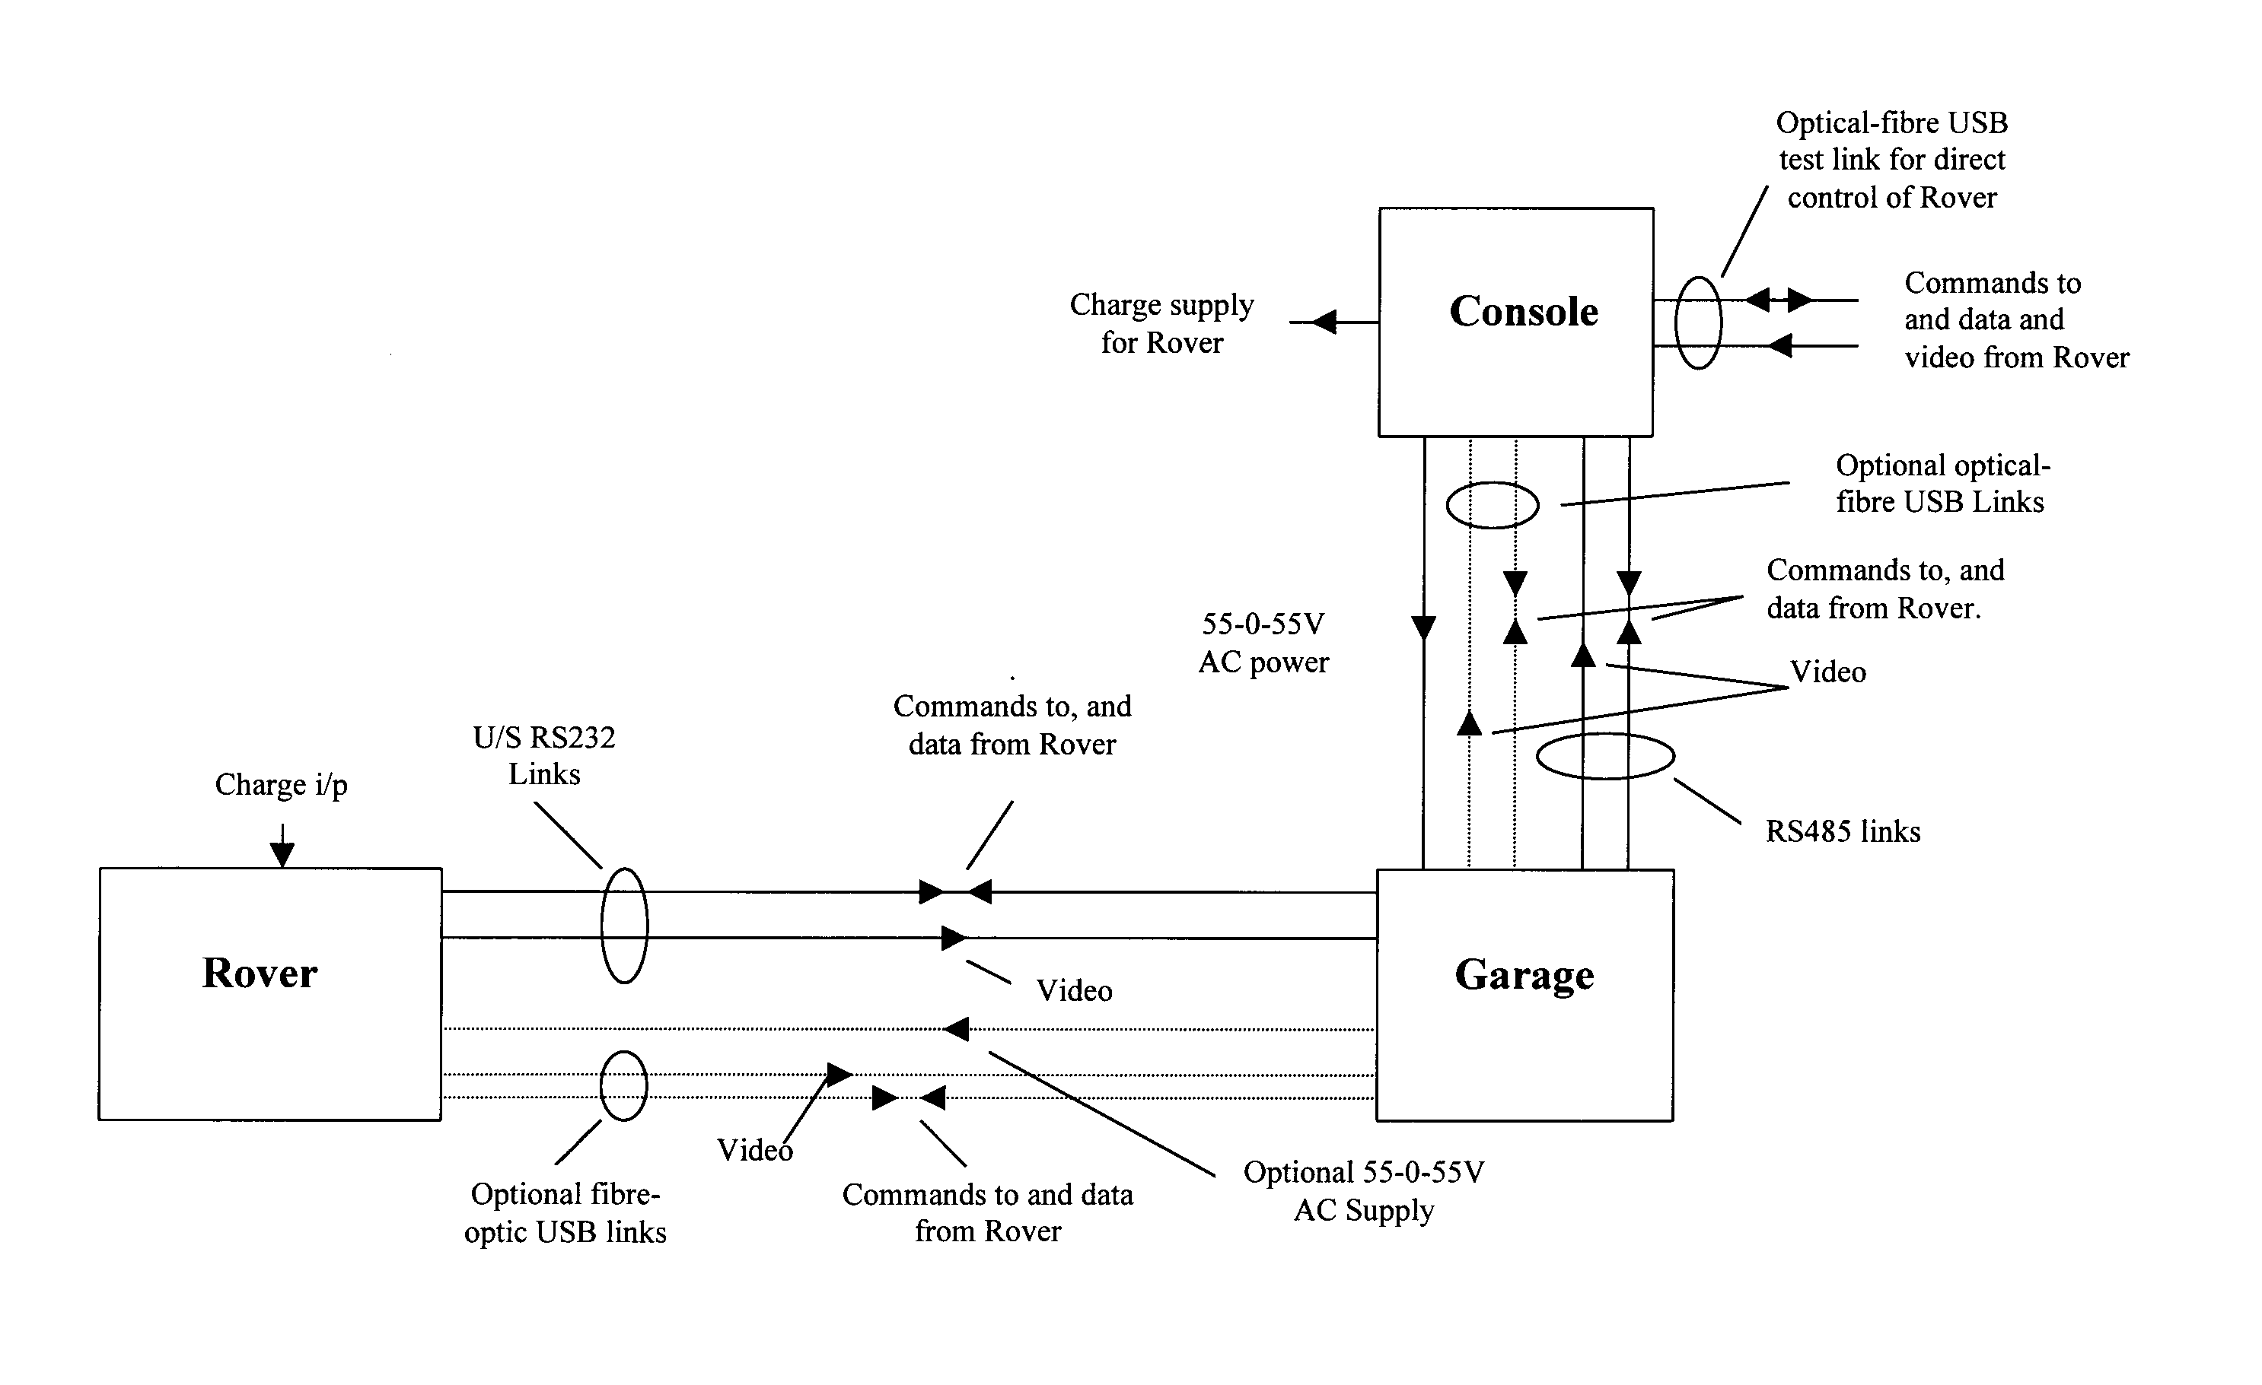

Figure 1. The Pearl Rover system

Note that the digital link is two-way, carrying commands to the Rover and data and video back, using an RS232 format. This requires two separate ultrasonic systems, one for each direction, operating at different frequencies in order to minimise cross coupling. Figure 2 shows a schematic of the FSK transmitter unit. For the prototype system the two ultrasonic frequencies used to carry the data are 95 and 105 kHz, with a data rate to 2.4 kb/s. The FSK receiver unit is shown in Figure 3.

5.2 Performance
The system was tested down the 4m model pipe described in section 4. Two tests, the control of a Pearl Rover and the transmission of low-rate video pictures via this water path were both successfully performed. The comparatively low data rate of 2.4 kb/s is due to the low ultrasonic carrier frequency of 100 kHz and to the use of high Q transducers. Operation with a carrier frequency of 250 KHz , together with the use of lower Q transducers, will allow a data rate of up to 9.6 Kb/s. In this test link, a motion JPEG coder/encoder was used to test the image transmission capability. At 9.6Kb/s rate, about 2 frames per second of 196x196 colour picture were achieved in our simulated water filled pipe.

Figure 2 The receiver for 2.4 kb/s underwater communications system

Figure 3 The transmitter for 2.4 kb/s underwater communications system

Further tests were made using narrow beam (10° overall), low Q (≤ 4), transducers with the scale model pipe. The scaled frequency was 1MHz, the pipe diameter 400mm., and the pipe length 4m. Only one multi-path mode was observed, and the system, using ASK, supported a maximum baud rate of 38.4 Kbs. With a burst length of 10 cycles, this represented a rate near the theoretical limit. To achieve this high rate the transducers must have very low Q’s so that the bursts are not extended into the guard periods. To test the performance of the link, it was connected between the serial RS232 serial output port of one PC and the serial input port of a second PC. The data consisted of a series of ASCII characters, and the errors were counted by comparing sent with received data. A worst case error count of 1 in 65,000 was measured. However, in noting this excellent performance it should be pointed out that the test pipe was straight and 4m long.

6. Conclusions
The focus of this project is to develop an acoustic data link specialized for water filled pipe environment. The channel identification for pipes is found to be more predictable when comparing with the shallow water channels. For control purpose, this system is adequate, however, for image transmission it is still not high enough and will be the main task of our research works.

References
1. M. Stojanovic, “Recent advances in high-speed underwater acoustic communications,” IEEE J. Oceanic Eng., vol. 21, pp.125-136, Apr. 1996.
2. R. Galvin and R. F. W. Coates, “Analysis of the performance of an underwater acoustic communication system and comparison with a stochastic model,” in Proc. OCEAN’94, France, Sept. 1994, pp478-482.
3. J.A.Catiporic, “Performance limitations in underwater acoustic telemetry”, IEEE Jour. Oceanic Eng. Vol.15, No.3, pp.205-216, July 1990.
4. M. Stojanovic, J. A. Catipovic, and J. G. Proakis, “Adaptive multi-channel combining and equalization for underwater acoustic communication,” J. Acoust. Soc. Amer., vol. 94, no. 2, pt. 1, pp. 1621-1631, Sept. 1993.
5. J G Proakis, “Adaptive equalization techniques for acoustic telemetry channels”, IEEE Jour. Oceanic Eng. Vol.16, No.1, pp.21-31, Jan 1991.
6. P. S. D. Tarbit, et al. “Development of a real-time adaptive equalizer for a high –rate underwater acoustic data communication link,” in Proc.OCEAN’94, brest, France, Sept. 1994, pp.I.313-I.316.
7. J Labat, O Macchi, “Adaptive decision feedback equalization: can you skip the training period?”, IEEE Trans. On Communication, vol. 46, no. 7, July, 1998.
8. P.C.Etter, “Underwater acoustic modeling: principles, techniques and applications”, Elsevier applied science, 1991.
9. M Stojanovic, J A Captipovic, J G Proakis, “Phase-coherent digital communications for underwater acoustic channels”, IEEE Jour. Oceanic Eng. Vol.19, No.1, pp.100-111, Jan 1994.
10. J. A. Catipovic, L. E. Freitag, “Spatial diversity processing for underwater acoustic telemetry”, IEEE J. Oceanic Engineering, vol.16, no.1, 86-97, Jan. 1991.
11. M Feder, J A Catipovic, “Algorithm for joint channel estimation and data recovery-application to equalization in underwater communication”, IEEE J. Oceanic Engineering, vol.16, no.1, 42-55, Jan 1991.
12. H. Kim, C. Sims, K. Nagpal, “Reduced order filtering in H-inifinity setting”, Proc., of American Control Conf., pp.1876-1877, 1992.
13. M Johnson, D. Brady, M. Grund, “Reducing computational requirements of adaptive equalization in underwater acoustic comm.”, Proc. OCEAN’95, San Diego, CA, vol.3, pp1405-1410, 1995.
14. D. Z. Liao, S. O. Harrold and L. F. Yeung, “An Underwater Acoustic Data Link For Autonomous Underwater Vehicles”, Proceedings of 1995 IEEE SICSPCS’95, 28-33, 1995.
15. S. O. Harrold, D. Z. Liao and L. F. Yeung, “Ultrasonic data communication along large diameter water-filled pipes”, M2VIP, pp239-244, Sept., 1995.
16. R. T. Bradbeer, S. O. Harrold, F Nickols, L. F. Yeung, “An underwater robot for pipe inspection”, IEEE M2VIP, Australia, 1997.
17. F. Nickols, D. Ho, S. O. Harrold, R. T. Bradbeer, L. F. Yeung, “An Ultrasonically Controlled Robot Submarine for Pipe Inspection”, IEEE M2VIP, Australia, 1997.
18. S. O. Harrold, D. Z. Liao and L. F. Yeung, “An Autonomous Underwater Platform”, M2VIP, 148-151, Sept., 1997.
19. Y. H. Li, S O Harrold, L. F. Yeung, “Experimental Study on Ultrasonic Signal Transmission Within the Water-filled Pipes”, Mechatronics and Machine Vision in Practice, Sept. 23-25, 1997, Australia.
20. B. LI , et al, “ Technical Report on the Long Distance Remote System”, Internal Report in Northwestern Polytechnic University.

Figure 2

