The Pearl Rover underwater inspection robot

Robin Bradbeer
Department of Electronic Engineering,
City University of Hong Kong, Hong Kong

Abstract
Pearl Technologies Ltd., was established by City University in 1997 to develop the prototype of an autonomous robot to inspect liquid filled pipes. This paper gives an overview of the project, and considers the commercial, design and engineering criteria that led to the development of the Pearl Rover.

The robot is of modular design with a common power, command and control chassis to which various propulsion mechanisms can be fixed. Two options are currently available; one a six-legged propulsion module and the other a tracked module. The overall design is detailed, with other papers in the conference looking in detail at the leg mechanism and the ultrasonic data link.

Keywords:
Underwater AUV, ultrasonic communications, pipe inspection, walking robot.

1 Introduction
Underwater robots began to appear just after the Second World War, mainly in scientific applications. The development of deep-sea oil exploration provided an economic boost to underwater ROV research, and most of the systems sold today are for such use.
Currently, the major use of underwater robots has been in open water where ‘swimmers’ are most appropriate. Limited development and use of walking and tracked/wheeled robots has occurred for specialist tasks. There are a number of existing ROVs to carry out tasks within ducts and pipes in which there is a continuous air pocket. However, there appears to be a significant number of circumstances where pipes are continuously or intermittently filled with water. In such circumstances, existing machines that depend upon RF communications are inadequate. And ‘swimmers’ are just not designed to work inside such a confined environment.
Previous work at City University of Hong Kong had laid the foundations for the construction of a prototype underwater inspection system that would be capable of meeting the needs of the market. [1], [2], and [3].

2 The market
Inspection of underwater, or liquid filled, pipelines has been tedious and dangerous, especially if a diver is used. Underwater pipelines normally lie on seabed at a depth varying from several meters at the shore to even hundred meters at the seabed. The degree of danger increases as the diver gets deeper and deeper into the pipeline. The diver cannot remain in the site for too long because of the scuba capacity and his physical strength. At the same time, the pipe size can be as small as 30cm. Thus it is not possible for an adult to work in such a confined environment. Manpower is the most valuable among the assets for a pipe inspection company. This raises the interest in unmanned autonomous underwater vehicle to replace human beings.
At the same time, many liquid filled pipes on land may be completely separate from a water environment, such as those in chemical plants, or they may be intimately associated, as with potable water pipelines and sewage pipelines. All of these pipelines, whether fully filled or not, suffer from similar problems. These problems are going to be encountered by a robot working in the piping system including the occurrence of gross marine fouling. This may be of soft growth, barnacles, bivalves or simple silting. Thus, a thick layer of slime and/or silt may be accumulated along the pipe bottom after a period of time. For inspection to be carried out efficiently it is also desirable not to stir up this silt. The pipeline may be tilted up, down or bent depending on the terrain.
There may also be fouling caused by obstructions, for example, loose bricks as are found in old sewage pipes. At the same time, the pipe may be in cylindrical or rectangular form. So, the inner surface may be curved or flat. Flat bottomed pipes can be accessed and inspected by tracked vehicles if the fouling is not too bad. However, circular pipes, or those with severe fouling, need another solution.

3 The Pearl Rover
Market research carried out in early 1996 showed that there was a potentially profitable market for a low cost ROV that could operate in water filled pipes without an umbilical. There seemed to be no particular preference for the type of propulsion used, although it was clear that there were some applications where wheels or tracks were more applicable, others where a different sort of propulsion was needed.
The ROV was therefore designed to offer the following unique functionalities:
- it can be operated in water filled ducts and pipes it can be operated without an umbilical
- it has high data transfer rate option if thin, armoured fibre optic umbilical is used which can double as a safety tether
- it can be reconfigured for optional motive power methods
- it should be designed so that it can support, and move, its own weight out of water.
This last point was considered most important as it meant that the ROV could walk or crawl into a liquid filled environment from dry land using the tether eg from the shoreline into the sea and then into a submerged outfall pipe.
Some field tests at the Black Point Power Station of CLP Power Hong Kong Ltd. proved the viability of using ultrasonic communications along a water filled pipe or duct, even one with a bend in it. Further tests showed that a normal commercial ccd-based video camera would give a reasonable picture in the environment for which the robot was designed..
The final design of the production prototype was decided at the end of 1998.

4 The modular concept
Market research showed that potential users of such an inspection robot would want to use it is both round and flat-bottomed pipes. It was decided that tracks would be best for flat-bottomed pipes and legs for round pipes, especially where there might be obstructions.
Consequently, two design teams were established to pursue both solutions. However, this meant that it was necessary to design a body/chassis that could contain the power, control and communications systems in such a way that it was easy for users to change the propulsion methods. It also allowed for the possibility of alternative propulsion mechanisms, such as propellers, to be added as an option at a later date

4.1 The chassis
A chassis (operating to a depth of 25m) was designed that contained the:
- control electronics
- ultrasonic communications system for fluid filled pipes (no umbilical required)
- fibre optic communications system for partially filled pipes
- power supplies
- attitude sensors
- camera and video recorder
The design of the chassis enabled different propulsion mechanisms to be easily attached. At present two mechanisms are available – a six legged unit for traversing rough terrain and circular pipes and ducts, and a tracked version for flat bottomed, relatively unobstructed, ducts.
The communications and control are designed so that in fully filled pipes/ducts or in still open water, an ultrasonic link can be used, thus obviating the need for an umbilical. In partially filled pipes or ducts, or in rough open water, environments, a light weight fibre-optic communications tether can be used.
The robot has an on-board high resolution video recorder which records the front camera picture as well as the attitude sensor data and time/distance information. A sampled, lower resolution, video signal is sent back to the control console. The robot is electrically powered, using on-board batteries, although the legs are powered by an in-house designed hydraulic system that makes use of the surrounding water.
The sensors included on the basic model include colour video inspection camera with pan and tilt and lights, ultrasonic obstacle detection and distance/depth/temperature/ heading/pitch and roll information. Because of the modular design, it is possible to fit optional sensors such as ultrasonic pipe profiling for navigation and guidance use. This can also be recorded, along with the sensor data, at the control console. A small black and white navigation camera is built in to the rear of the robot to allow ease of extraction from the pipe or duct. Figure 1 shows the overall system diagram.

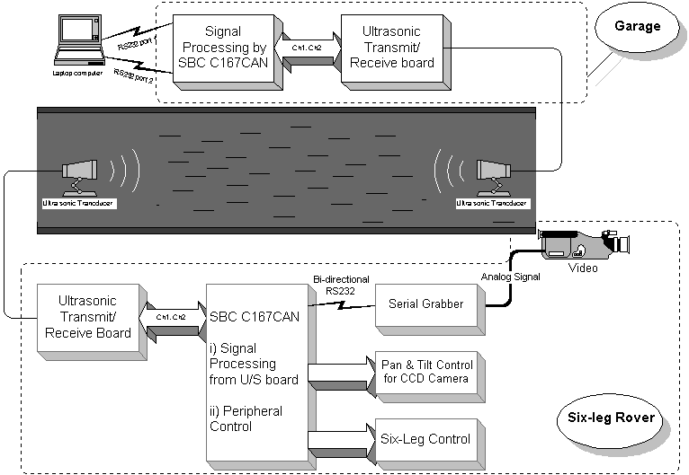

Figure 1: Overall system diagram

To protect the ROV whilst it is being lowered and raised into the pipe, usually through a vertical access point, a stainless steel garage is used. This garage also contains the communications electronics for the ultrasonic communications link and is itself linked to the base station via an umbilical. Figures 2 shows the tracked version of the robot with its grp casing inside the garage . To minimise weight, maximise robustness and durability, titanium is used throughout the chassis, leg and hydraulic system, and tracks mechanism.

Figure 2: Tracked ROV in protetctive garage
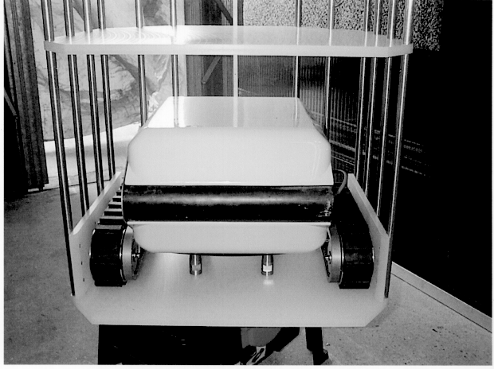
The outer casing is of a streamlined design manufactured from a lightweight composite material. It is designed to allow water to flow through the body to avoid unnecessary drag and excessive buoyancy.

4.2 The leg mechanism
The leg system is described in detail in an associated paper [4]

4.3 The tracks
The tracks are designed to attach to the side of the chassis once the front and rear leg assembly has been unbolted. The control system for the tracks, as well as the 12 V power supply, is provided by the control electronics in the chassis unit. The track mechanism contains the drive electronics. An outline drawing is shown in Figure 3.
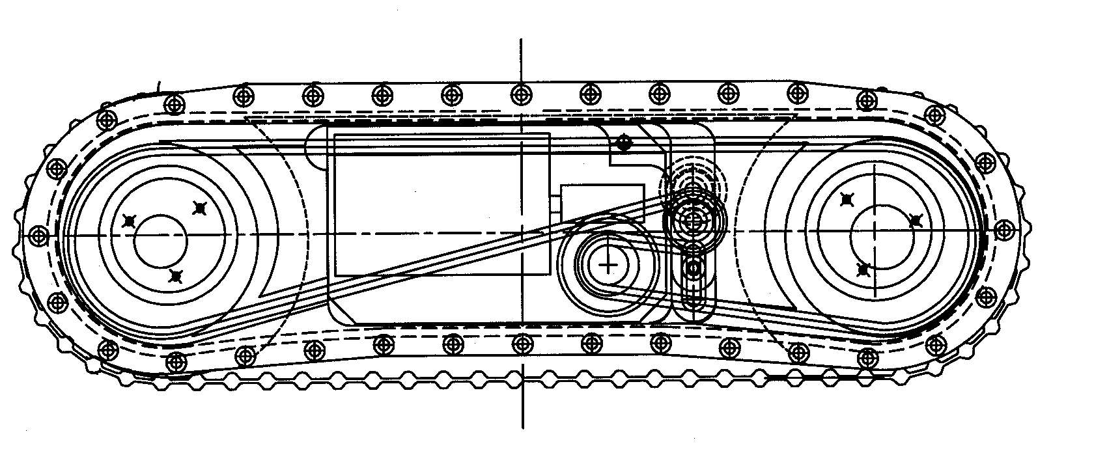Figure 3: Outline drawing of the tracks

The tracks use two Maxon 118894 12v brushless dc motors. This was fitted with thrust bearings and a 40:1 worm drive gear assembly which was mated to a 10 tooth chain drive sprocket within the track assembly. The track case was milled to channel this chain either to one drive cog when driving a track belt or to both drive bosses when the wheeled option is chosen. Both combinations are driven via a 30 tooth cog thus affording another 3:1 gear ratio reduction within the track unit. This produces the required torque and track speed of 200mm/sec.
The Maxon 109982 motor speed controller card is used to control the tracks and interfaces with the chassis control electronics via an RS232 link.
The maximum speed of the track is 200 mm/s, with a maximum working depth of 25 m. They have a mission life of 4 hours, with an estimated mission length of 500 m. The 12v system used by the ROV can pull up to 25kg. As this item will also be sold separately from the ROV a 24v version is available. This can pull up to 35kg.

4.4 The communications system
The ultrasonic communications is described in an associated paper [5]

4.5 The control system.
The ROV is controlled from a base station, usually close to the access point of the pipe under investigation. The base station consists of a PC with both display graphics and video graphics capability. It is therefore possible to have the video from the camera system displayed in a window at the same time as the sensor data.
The input to the base station comes from the garage communications electronics module. This takes the RS485 commands from the console and coverts them into an ultrasonic beam for transmission to the ROV. It also takes the return ultrasonic data and converts this into RS485 for transmission to the console. A similar link, at a different ultrasonic carrier frequency, is used for the video system.
The base station contains a video recorder that records the realtime information coming over the video link. This would normally be a sampled image from the main colour ccd camera in the ROV. The on-board video recorder will record high resolution images for viewing after the mission has ended. The sampled video is basically for navigation and preliminary inspection.
If a fibre optic umbilical tether is used then the console video record will record high resolution images, and the on-board video will be used as backup if the main link fails.
The console has an RS232 interface which can be plugged into the ROV when it is on land. This is used to provide a direct communications link between the host computer and the various processors on board the vehicle, so that update or upgrade reprogramming can be carried out, or diagnostic routines run.
Figure 4 shows the overall control system schematic.

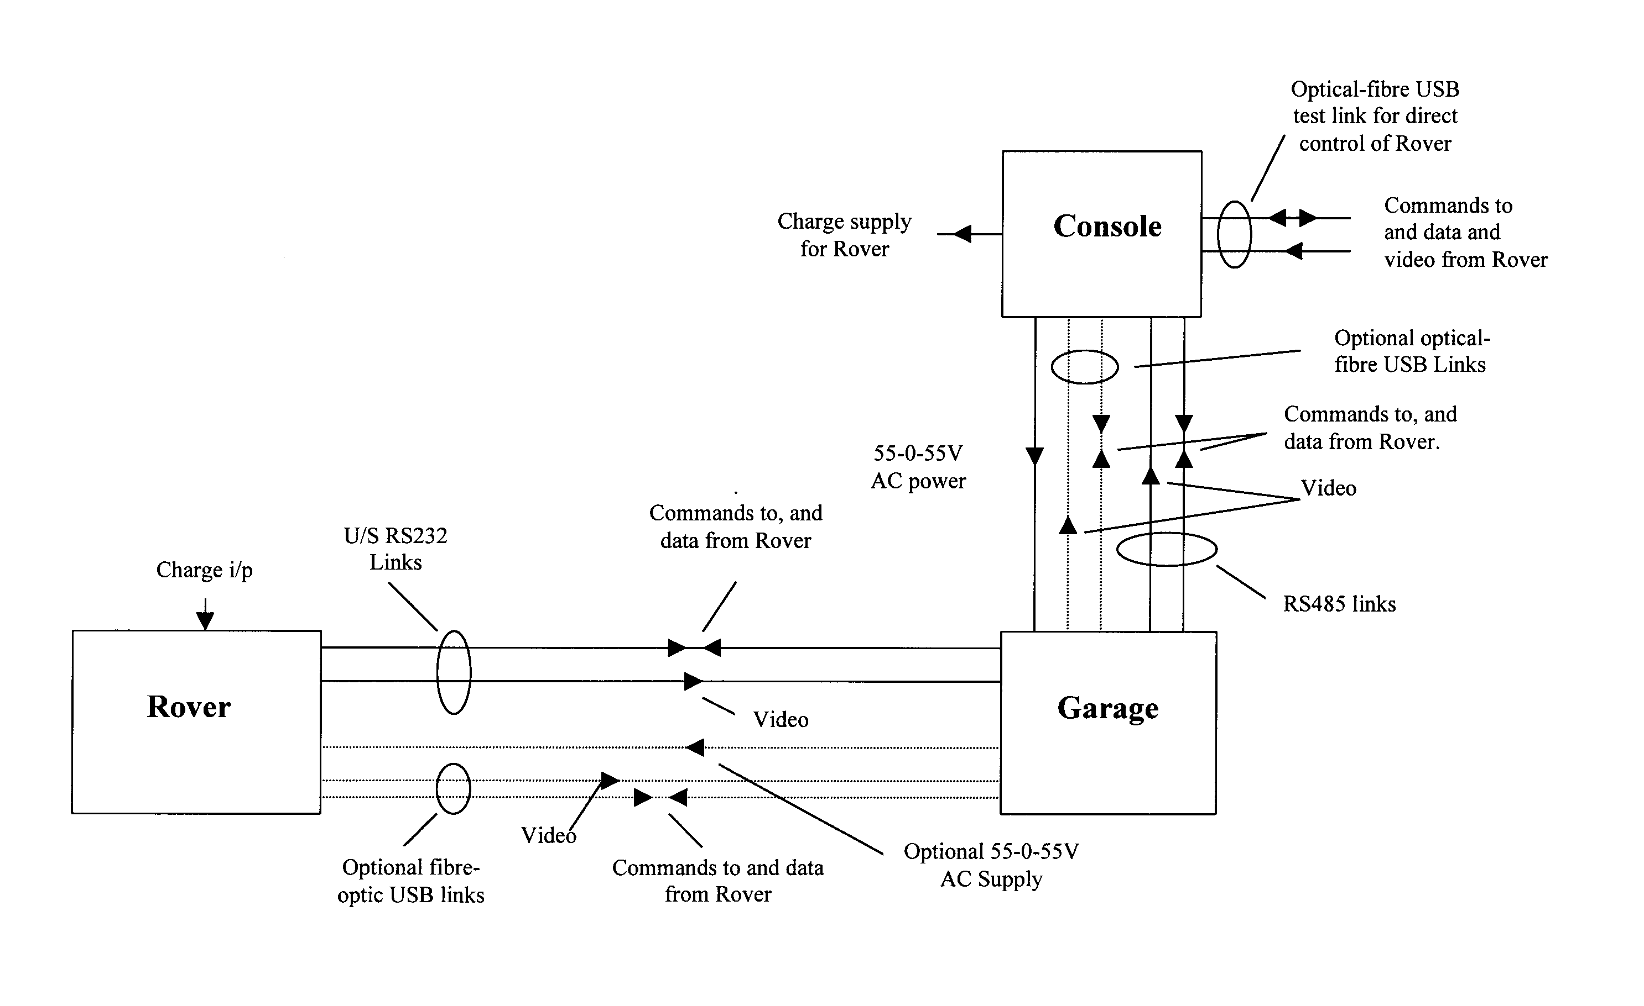

Figure 4: The overall control system diagram

5 Conclusions
An underwater remote operated vehicle has been designed and constructed that has the ability to use different types of propulsion mechanisms. Currently, a tracked and six-legged options are available.
The ROV uses an ultrasonic communications system to send realtime data and sampled video along fully filled pipes. The addition of a fibre-optic tether allows the sending of both realtime data and video along partially filled pipes.
Figure 5 shows the operational tracked ROV and Figure 6 the six-legged prototype.
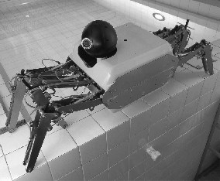
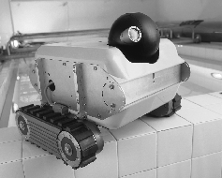
Further developments include the improvement of the gait for the legged version, as well as increasing the speed of the ultrasonic communications link allied with video compression technology so that real-time vide may be sent without the use of the tether/umbilical.

Figure 5: Legged ROV Figure 6: Tracked ROV

6 References
[1] S O Harrold, D Z Liao and L F Yeung, "Ultrasonic data communications along large diameter water-filled pipes" Proceedings of 2nd International Conference on Mechatronics and Machine Vision in Practice (M²VIP'95), pp 239-244, Hong Kong 1995
[2] F Nickols, R. Bradbeer and S O Harrold "An ultrasonically controlled autonomous model submarine operating in a pipe environment", Proceedings of 4th International Conference on Mechatronics and Machine Vision in Practice, (M²VIP97), pp 142-147, Queensland, Australia, 1997.
[3] R. Bradbeer, S. O. Harrold and L. F. Yeung, "An underwater robot for pipe inspection", Proceedings of 4th International Conference on Mechatronics and Machine Vision in Practice, (M²VIP97), pp 152-156, Queensland, Australia, 1997
[4] H.W. Ho, B.L. Luk, R. S. Bradbeer, L. F. Yeung, H.J. Zhang and M. Mould , “The design of a hydraulically powered leg for an underwater six-legged robot”, Proceedings 6th International Conference on Mechatronics and Machine Vision in Practice, (M²VIP97), pp ?-?, Queensland, Australia, 2000.
[5] B Li, S O Harrold, L F Yeung and R Bradbeer, “An underwater acoustic digital communications link”, Proceedings 6th International Conference on Mechatronics and Machine Vision in Practice, (M²VIP97), pp ?-?, Queensland, Australia, 2000.

