An Online Multimedia Learning System for First Year Laboratory

Dennis Chan T.Y. and Robin T. Bradbeer

Department of Electronic Engineering
City University of Hong Kong
83 Tat Chee Avenue, Kowloon Tong, Hong Kong

E-mail: eertbrad@cityu.edu.hk

Abstract: This paper describes the design and implementation of a multimedia interactive laboratory modules to take first year students through an introductory lab experiment. The experiment is currently carried out by all first year students in the Department of Electronic Engineering at City University of Hong Kong (CityU). The objective is to provide an interactive lab manual that can be accessed through the university’s intranet, or over the web by students at home. The system allows students to have a more interactive role with the traditional laboratory manual. In addition, it is designed to equip the students with a strong foundation before attempting the laboratory works in reality. The content must be able to be viewed with a DHTML enhanced Web-browser with necessary plug-ins or ActiveX components installed.

Keywords: Web-application, laboratory support, electronic engineering

INTRODUCTION

Online Education is becoming popular with the evolution of the World Wide Web. The Web could play a role in improving teaching and learning. We can see a lot of universities are making use of the Web to deliverer web-based training and information sharing in USA.

In Hong Kong, the number of people accessing Internet is increasing in the past few years. University students are automatically assigned an Internet account once they entered the school. However, using the Web in the area of educational enhancement is still in primary stage.

To facilitate the use Internet resources, the department of electronic engineering at City University of Hong Kong (CityU) decided to construct an online laboratory support module for first year students.

The objective of this project is to build an online multimedia learning system in supporting the first year laboratory. The system allows students to have a more interactive role with the laboratory manual. In addition, it is designed to equip the students with a strong foundation before attempting the laboratory works in reality. The content must be able to be viewed with a version

4 Web-browser with necessary plug-ins or ActiveX controls installed.

A previous version of the laboratory manual was based on a standalone system [1]. The online system was created on the basis of this previous version.

LABORATORY MODULE

The laboratory modules supported in this online system include; a step by step guide to soldering practice, which contains a number of videos and images to illustrate the basic of soldering techniques; and a step by step guide to building a stabilised power supply. The tutorial contains a number of animations, interactive questions, diagrams and images to help students building the power supply.

The power supply experiment itself is based around a metal chassis as shown in Figure 1. A mains transformer has four 5 V secondary windings. These are terminated in four fused connectors. There are two 3055 transistors, a 1kΩ variable resistor and a component board on the metal chassis.

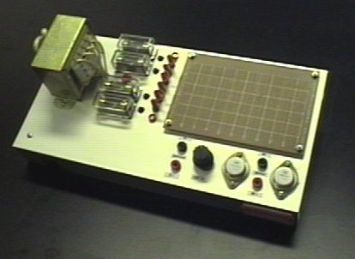
Figure 1 The power supply project kit

The experiment starting from soldering techniques to transformer properties, from a half and full-wave rectification to capacitive filtering. The zener diode is then introduced as a regulating element. The final part of the experiment is the introduction of feedback regulation, by using a motor-generator feedback loop.

A series of optional units are provided for students to carry out after finishing the basic experiment.

The laboratory manual contains some electronic theories, and students are expected to study outside the laboratory and do some background work before they get started. It would be a bit difficult for a fresh man to do his own pre-lab. The online system allows students to have more interactive role with the laboratory manual and helping them to do pre-lab session.

SYSTEM DEVELOPMENT

Multimedia content can be easily delivered through the use of CD-ROM or high speed LAN. However, to deliverer multimedia content through WWW is difficult, because of the bandwidth constraint.

As stated above, the online system was based on the developed standalone system. The original system was developed with Multimedia Toolbook 3. A number AVI movie clips included for demonstration. We tried to investigate the possibility to convert the system directly to web ready. It could be done with the Toolbook II, a newer version of Toolbook. However, it was found that the bandwidth requirement of Toolbook II is high because of the file size problem. In addition, the plug-in size of Toolbook II is about 6 Mega byte, which is not acceptable. The Toolbook II files should be fully downloaded before playing is another drawback [6]. As a result, the waiting time is long compare with general text based HTML and image files.

The second approach we investigated was to re-construct the system with other lightweight Web multimedia technologies. The solution we selected are Dynamic HTML, Shockwave Flash, Real Video and web standard image files. The system was implemented with these technologies to create the online system because of their streaming capabilities and lightweight file size.

Dynamic HTML (DHTML) [2] is the latest technology of version 4 browsers. DHTML allows content to be displayed with more design flexibility, accuracy and interactivity through the use of Cascading Style Sheets (CSS) [3] and scripting language such as JavaScript. DHTML improves the functionality and inactivity of an HTML document. The functionality of DHTML is controlled by the browser’s Document Model (DOM). A DOM defines how pieces of an HTML document are exposed to scripts. However, the Document Object Model (DOM) [4] of MS IE and Netscape Navigator are different. This makes the cross-browser development difficult. The solution at this moment is two white two versions of script to accommodate different DOMs. To bring some solidity to the object model, the DOM standard is now under development by WWW Consortium (W3C).

Shockwave Flash is a vector-based graphic and animation de facto standard on the Web. It is capable of stream playing and simple interaction with user mouse click [5].

Real Video is a streaming technology that delivers movie clips without long waits over the Web-server low bandwidth connection such as dialup modem.

SYSTEM REQUIREMENTS

The system was designed based on the Dynamic HTML concepts with cross-browser approach. The users are required to have the version 4 browsers, either MS IE4 or Netscape Navigator 4. In addition, a Flash player and a Real player plug-in/ActiveX installed to facilitate the multimedia content.

THE NAVIGATION WINDOW

When a user click a launching button on the Web browser, a new Web browser window will popup. The popup window is used to display the whole courseware. The screen is divided into two frames, a content frame and a navigation bar as shown in Figure 2.

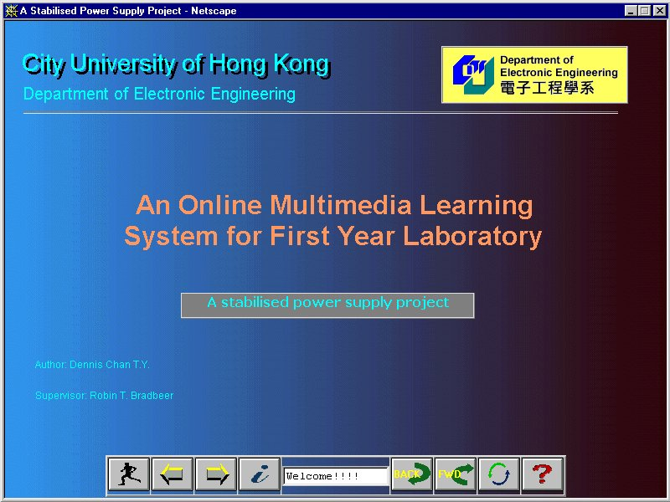
Figure 2. The navigation window (Netscape)

The navigation bar stays on the navigation window once loaded to the browser. Each button is assigned with a JavaScript function to react with user’s action. The navigation bar read the content page’s JavaScript global variable such as page information, next page URL address, and previous URL address to load the related HTML page to the content frame.

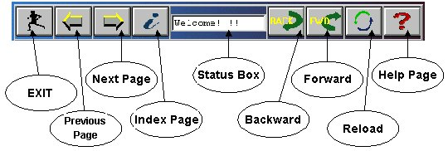
Figure 3 Navigation bar outline

SYSTEM DESCRIPTION

The system allows students to navigate the courseware by using a mouse pointer.

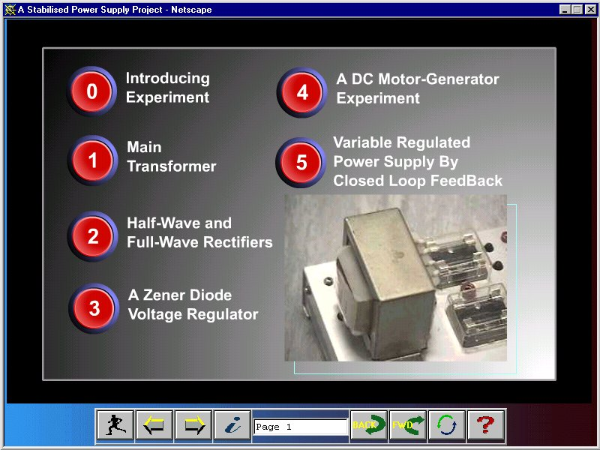Figure 4. The Index page

They can jump between linked pages or to trigger some functions such as show hide a picture or answering questions. Figure 4 shows an Index page for students go to a specific page directly.

To play the soldering demonstration movies, a Real Video movie player is embedded inside the content page with a simple controller and a connection speed selection. The Real Video quality is proportional to the bandwidth selection. Figure 5 shows an example of using Real Video; the controller is located on the right hand side.

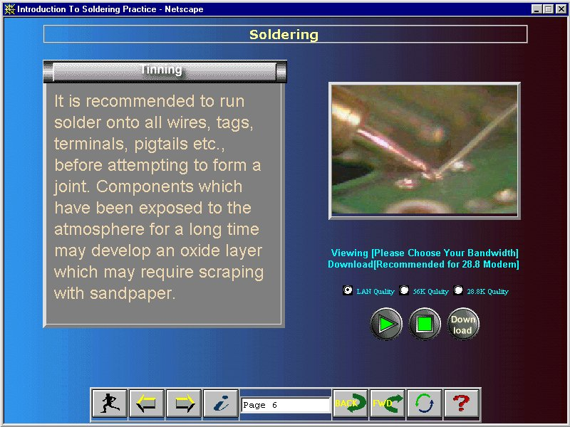
Figure 5. Real Video controller

One of the features of DHTML is that of layering capability and positioning. Figure 6 shows example of layered page. When the user clicks a button, the hidden layer would show. When the user clicks the shown layer again, it would hide away. This mechanism is done with the JavaScript show/hide layer action.

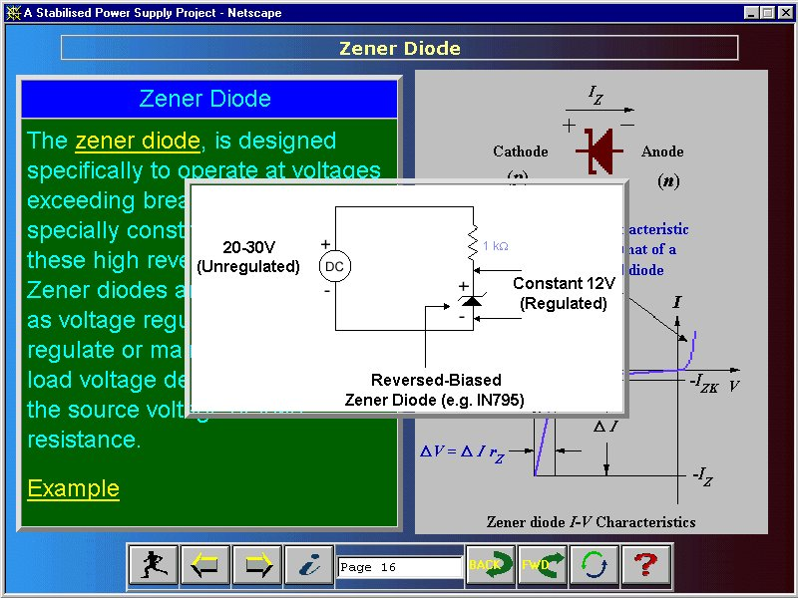
Figure 6. A layered DHTML page

The interactive question is another important feature of the multimedia system. Under the web environment, JavaScript is chosen to interact with a user event. Figure 7 shows a page describing the definition of percent of regulation. The system allows the user to select an answer by checking an appropriate check box. The result is immediately shown.

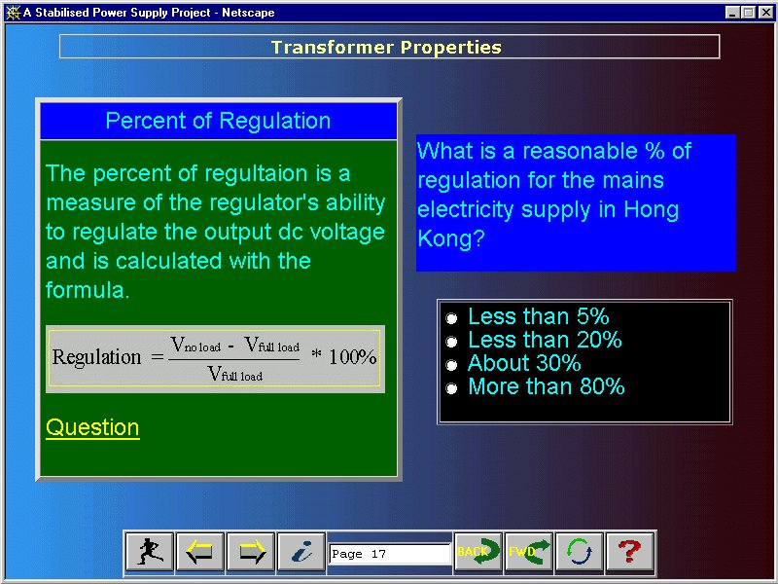 Figure 7 Interactive question

In this system, animations were made with Shockwave Flash. The file size of Flash is small when compare with animated GIF or Java applet.

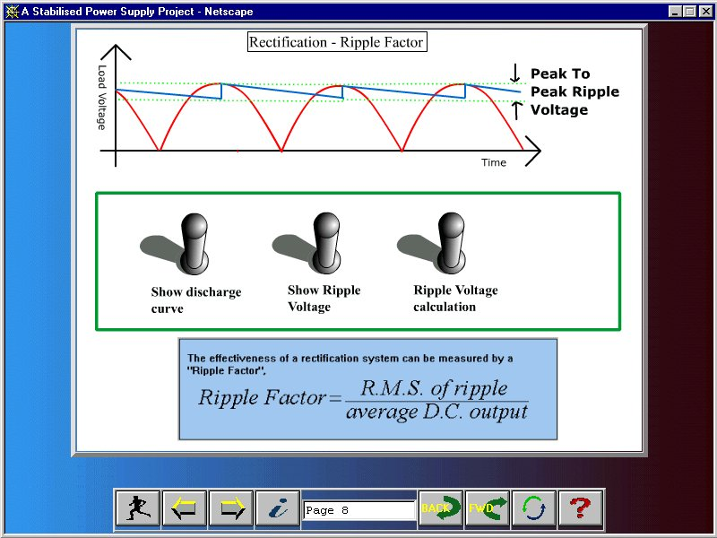
Figure 8 Flash animation.

Figure 8 shows an example of using Flash in describing ripple factor. Shockwave flash animation is getting popular on the Web because of the small file size and strong interactivity. Flash would govern the future of Web publication as Macromedia, the owner of Flash, has announced the establishment the Shockwave Flash file format as an industry standard. The future version of Web browsers should have Flash plug-in preinstalled.

FURTHER DEVELOPMENT

This project focuses on the interface design, so some of the functions of the standalone system was not implemented, for example, the search function and bookmark function. The search function involves server-side CGI scripts to do so. The bookmark function can either be implemented with client-side cookies or server-side CGI scripts.

CONCLUSION

An online learning system supporting first year laboratory was created with the latest Web multimedia technologies such as Dynamic HTML, Real Video and Shockwave Flash.

REFERENCES

- J Wong and R T Bradbeer, " Development of a multimedia based teaching programme to support a first year Electronic Engineering Teaching Laboratory" IEEE Second International Conference on Multimedia in Education, Melbourne, Australia, Jul. 1996.
- For more information of DHTML, please visit the DHTML Zone created by Macromedia. http://www.dhtmlzone.com/index.html
- CSS recommendation can be found at http://www.w3.org/Style
- DOM recommendation can be found at http://www.w3.org/DOM
- Macromedia Flash 2 online electronic documentation, http://www.macromedia.com/support/flash/docstuff/edocs/edocs.html
- Demonstration of ToolBook II can be found here, http://www.asymetrix.com/products/toolbook2/neuron/showcase.html

