WWW Implementation of existing stand-alone interactive courseware

Connie Chan Wai Man and Robin Bradbeer

City University of Hong Kong
Kowloon Tong, Hong Kong

email: eertbrad@cityu.edu.hk

Abstract

Current teaching methodology in Hong Kong is oriented toward lectures and written examination, and encourages only passive learning. This approach is ineffective for today’s students. To lead student’s real learning and understanding, the traditional teaching method should be changed to co-operative and interactive techniques. City University of Hong Kong (CityU) has implemented a series of programmes to overcome these problems.

The Department of Electronic Engineering at CityU has for some years been using the courseware developed by the Electronic Design Education Consortium (EDEC), which is part of the Teaching and Learning Technology Programme, a major initiative of the UK Higher Education Funding Councils. Unfortunately, EDEC courseware is designed to be used mainly in stand-alone mode. This presents many problems for a fully ‘wired’ university, like CityU, where WWW access by students from home is encouraged, using the university’s intranet. This paper the method used to enable the EDEC courseware to be accessed on the Web under a Shockwave environment.

Design and Implementation

3 EDEC modules were chosen as vehicles to test the methodology. The first one is Finite State Machine (FSM) module. The others are Bistables Circuit module and Clocking Circuits and Timing module.

A number of steps are needed to convert an EDEC module. These are:

- Defining the implementation method: Build a new 2-way interface using Authorware.
- Developing and designing an EDEC module inculded module layout, button bar, movie and navigate and glossary files.
- Porting the old module.
- Package the Authorware application.
- Compress the application using Afterburner program.
- Embedding a “shocked” application with HTML.
- Setting up Web server for Shockwave for Authorware.

Building a new 2-way interface using Authhorware

Before creating a multimedia courseware on the Web, it was necessary to study and analyze the EDEC C Shell.

The EDEC C Shell is written in C and was complied using Borland C++ under Windows 3.1 platform. The main function of the Shell is to provide a consistent look and navigation throughout the courseware material produced within module. It allows the end user to control the navigation within the Authorware application by supplying the standard button bar displayed at the bottom of the Authorware presentation window.

Once the EDEC C Shell is written, it needs to be compiled into a form of DLL (Dynamic Link Library) and import into Authorware file. A DLL is an executable module containing functions that Windows applications can call in order to perform useful tasks. However, DLL can only be run on the Windows platform. For the Macintosh platform, it needs to be rewritten and recompiled to another format. As the architecture of different operating systems is different, a rewrite and recompilation of the codes of the Shell are needed in order to provide cross platform solutions. Hence, two different versions, even more if run on other platforms as well, of the EDEC C Shell are needed to maintain a single courseware!
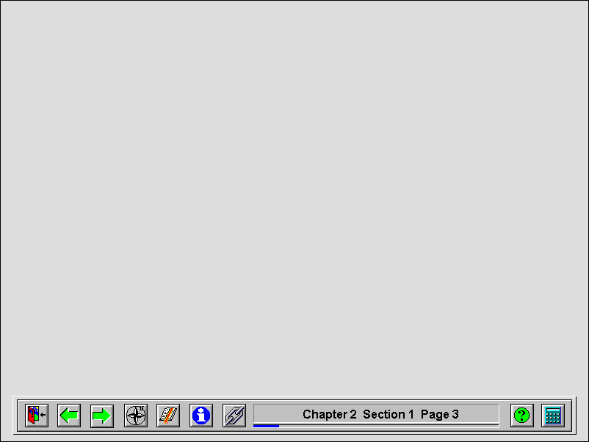
Button Bar &
Status Window
Main
Area
Because of the limitations of using EDEC C Shell in the courseware, it was decided that this would not be extended and implemented in this project. Alternately, a new interface was built using Authorware.

The new button bar interface of the application does the same functions as the EDEC C Shell does. It is built by many of the variables and functions inside Authorware that need to be considered during its design. Using these variables and functions, an application can be made as necessary. These variables and functions are the "hidden" jewels of Authorware. It unlocks the full functionality of Authorware. The new module structure is much simpler than the existing one.

Due to inhabit the feature of multi-platforms of Authorware, once an Authorware file is created, it can run on any platforms (“Author Once, Publish Anywhere”).

Developing and designing an EDEC module inculded module layout, button bar, movie and navigate and glossary files

After it was decided to replace the implementation method of the existing EDEC C Shell with the new interface using Authorware, the next step was to develop a whole EDEC module to make it suitable to access from the Web.

The development of a whole EDEC module can be mainly divided into 4 working areas:

- Module Layout Design
- Button Bar Interface Design
- Movie Design
- Navigate and Glossary File Design

Module Layout Design

To design a module layout, a standard and simple outlook should be maintained among all the courseware. The layout of the screen consist of two parts:

- The main area where the course material is to be displayed
- And a panel of button bar and a status window

Figure 1. Module Layout

2. Button Bar Interface

The button bar interface design is a very important part of EDEC courseware. It allows the user to navigate through the module in various different ways, and to display information about the current session. Authorware is used to build this interface. Figure 2 shows the button bar interface.

The framework that provides control and navigation through the courseware is divided into three parts: -

- The Standard Toolbar Buttons – e.g. Quit, Previous, Next, Index, Bookmarks, Information and Links – allows the user to navigate through the module in various different ways, and to display information about the current session.
- The Message Window and Progress Indicator
- Optional Toolbar Buttons – e.g. Help and Calculator – provides additional features.

3. Movie Design

As all movies in the existing EDEC courseware use AVI (Audio Video Interleave) format. One of the disadvantages in using AVI files for Web playback is that Mac users have to convert the files to another format for playback. Built-in support for AVI in Netscape Navigator is limited to Windows 95 and Windows NT versions. Most importantly, “download and play” technology is used when the video format is AVI. The size of the video largely affects the performance of the accessing time of an application on the Web. For example, the movie used in the Bistable Circuits module is almost 11M in size, it takes 50 minutes for the user to download whole the video, even more for a slow connection to the network, which only takes 42 seconds movie to play. Therefore, there was no hesitation in changing the AVI format to RM format.
Quit
Previous
Next
Index
Bookmarks
Information
Links
Status Window
Help
Calculator
Standard Buttons
Optional Buttons
Progress Indicator
Figure 2. A 2-way Button Bar Interface
Since RealVideo is a streaming video format, which is the continuous delivery of time-based media, such as animation, audio, or video, to a user’s machine, it was chosen to convert the format of the movie. The user doesn’t have to wait for the file to be completely downloading before viewing the content. The rest of the file is downloaded from the server – streamed in the background while the animation or other time-based media plays on the client’s computer screen.

Changing the video format can reduce the movie size from 11.3MB to 120KB. It was reduced about 10 times than before. Not only the delivery speed was increased but also it is easier to store. On the other hand, although the RM movie quality was poorer than AVI, it is still acceptable. Most importantly, AVI uses “download and play” technology while RM uses streaming technology. The streaming technology enables fast playback across Intranets. Therefore, the performance of the module accessing from the Web was greatly improved.

In order to link from RealVideo file to a web site, a Metafile (.RAM file) is needed to be created.

Metafiles are text files, which contain the URL location of a RealMedia (.RM) file. However, it cannot be referenced directly by the Web page because this would cause them to be downloaded in their entirety before playback. In order for the video files to be played in real time, they must be played through a RealPlayer, and served by a Real Server. Therefore there must be a link between the Web server and the Real Server. The link is contained in the metafile. Figure 3 shows the procedure to call a RM movie when a button is clicked.

4. Navigate and Glossary Files Design

Navigate and Glossary files are two standard files used in EDEC module. The Navigate file is a help file to guide the user how to use the buttons in the standard toolbar. It is used in the Help button. The Glossary file contains all the special terms as well as examples that appear inside the module. It is used in the Link button.

In the existing EDEC module, these two files were written by MS Word and then compiled by some help editor, for example HelpEdit, to form Navigate.hlp and Glossary.hlp. When they run, an executable program, Winhelp.exe, was called.

However, a .hlp file can only be run on the Windows platform. It meets the same problem as EDEC C Shell met. Therefore, to let the Navigate and the Glossary run on multi-platforms, it was necessary to be rewrite and recreate them using Authorware.

To develop these two files, was not so difficult because only navigating within the application and text needed to be managed.

Porting the old module

After finishing the development stage of the EDEC module, porting the old module materials into the new module was performed. The modules developed with the EDEC C Shell can easily be moved into the new module’s format. The porting process can be done in 2 steps:

- All the codes comprising the EDEC C Shell have to be removed.
- The new design in the development stage should now be imported. It was not easy, but depending on the structure of the original module can be done.

Package the Authorware application
Figure 3. Procedures to call a RM movie when “Watch the movie” is clicked.

In order to turn a standard Authorware piece into a shocked Authorware piece, the piece should be packaged first. To package an Authorware piece, choose “Package” under File menu in Authorware. Then, select “Without Runtime” in the Package dialog box as well as “Package all libraries internally”, the Authorware Plug-in will serve as the runtime application for users.

Compressing the application using Afterburner Program

An Afterburner program is a utility to compress and segment a packaged Authorware file - including libraries - to a shocked Authorware piece. It will compress the file by 50 to 75 percent so they can be delivered over the Intranet as efficiently as possible, without requiring long waits for downloading. It also enables the designers to export compressed Authorware applications for the Web or import compressed files for editing.

Afterburner produces two types of files from an Authorware piece:

- One or more segment files (extension .AAS), each segment containing a compressed section of the piece.
- One map file (extension .AAM), which contains information the Authorware Plug-In needs to retrieve each segment and to retrieve external files used with the piece, such as movies and DLL.

One of the important parameter affect the performance of the courseware is Segment Size.

The default segment size is 16,000. However, when the courseware segmented with this size was tested, the transfer rate was very slow, especially when loading large graphics. When the segment size is adjusted from 1,000 to 16,000, the performance is very different. If the size is small, say 1k, the amount of transferring data from the server is increased. If the size is large, say 16k, the amount of transferring data decreased but the loading time is longer. There is a trade off.

In order to find the optimal value, it is necessary to test and try it! Finally 4,000 was chosen as the default segment size to segment a courseware. When downloading a particular page in a courseware, the time for texts and graphics to appear is within 5 seconds even in a slow modem connection.

Once the Authorware file has been compressed, it cannot be reopened with Authorware. The user can select and download those parts that are interested in. All other items will not be downloaded until the user selects them. As the size of each segment files are small, it results in much shorter waiting and downloading times.

Embedding a “shocked” application with HTML

To add shocked Authorware pieces to Web pages, the HTML tag, EMBED is used. This specifies the location of the piece and a rectangle within the page where the piece will be displayed. The EMBED tag is used not just a Shockwave piece but also for other types of data objects which can be viewed inside Web pages with the aid of browser plug-in. The EMBED tag is easy to use and takes the following form:

<HTML> <HEAD>
<TITLE> Clocking Circuits and Timing Demonstration</TITLE>
</HEAD> <BODY>
<EMBED SRC="cir.aam"
WINDOW=onTop PALETTE=Background>
…
</BODY> </HTML>

The WINDOW setting tells how the Authorware piece is displayed in relation to the Netscape browser. When onTop is set, the Authorware application displays in a separate window on top of the browser window. This makes the application look more like a stand-alone application. The PALETTE setting determines which color palette the browser uses on Windows computers. When Background is set, the shocked Authorware piece uses the browser’s color palette.

Setting up Web Server for Shockwave for Authorware

To serve Shockwave pieces from the Web site, the Web server needs to be set up to associate MIME type application, subtype x-authorware with extension .AAM, .AAS, .BIN. When transfer the shocked Authorware application to the server, they must be transferred in binary mode and as raw data if the FTP software has that option.

Instead of configuring the server, a parameter EMBED tags can be included that will tell browser the MIME type of the EMBEDDed file. To run an Authorware MIME type, the TYPE to be added should be:

<HTML> <HEAD>
<TITLE> Clocking Circuits and Timing Demonstration</TITLE>
</HEAD> <BODY>
<EMBED
Type="application/x-authorware-map"
Type="application/x-authorware-seg"
Type="application/x-authorware-bin">
…
</BODY> </HTML>

The “application/x-authorware-map” is to run the map file with the extension of .AAM. The “application/x-authorware-seg” is to run the segment files with the extension of .AAS. The “application/x-authorware-bin” is to run the external binary file with the extension of .BIN. It may be a movie or DLL.

Use of EDEC courseware

In order to view the EDEC module on the Web, a Shockwave Authorware plug-in needs to be installed in the Shockwave-capable web browser namely Internet Explorer 3.0 – 4.0x Final Release or Netscape Navigator 2.02 – 4.04.

Shockwave Authorware plug-in provides the capability to display a shocked Authorware application within the browser. A link was provided to let users download the appropriate plug-in if they have not installed before. This plug-in is a freeware can be downloaded from Macromedia’s Web site (http://www.macromedia.com).

Conclusion

The EDEC courseware was successfully developed, and it has been shown that it is possible to take courseware written for stand-alone use and recode it for use on the Web.

As the existing EDEC courseware was burn on a CD-ROM and run on a personal computer while the new module was put on the file server and run with the web browser under Shockwave environment, the size of the module was greatly different. The following table shows the size of the module under these two different environments.

EDEC Modules | Before | After
Bistables Circuit | 1.2MB | 530KB
Clocking Circuit and Timing | 2.3MB | 930KB
Finite State Machine | 3.2MB | 480KB

According to the table, it was clearly shown that the sizes of the modules were greatly reduced about 60-85 percent after reformatted. As the size of the module was small, one of the advantages, it was easier to delivery and storage.

Using Authorware development tool, it can create reusable structure templates, add or replace media without modifying the application!

References

- Macromedia Web Site. (http://www.macromedia.com)
- EDEC Web Site. (http://edec.brookes.ac.uk)
- http://www.ee.cityu.edu.hk/~edap066

